**CREATING LINKS TO SHARED DOCUMENTS 2/12/18**

**You’ll need to upload the documents in order to link to them.** There are **two ways** to do this.

**Before You Start**

* Consider your audience. Will they have the software to open the file?
* We recommend converting Word, Excel and PPT documents to PDF format when linking from a web page. But first make sure your documents are created with proper headings and image tags before converting to PDF.
* Prepare the files for upload beforehand so that you know where they are on your computer.
* The file names should be lower case, with no spaces. Note: You can rename the files after uploading to OU Campus.

**Uploading Multiple Documents to OU Campus**

1. LOG IN to OU Campus.
2. CLICK the Content Tab.
3. NAVIGATE TO FOLDER where you manage PDF files (usually PDF folder). Consider if there is a a subfolder, such as academic year for governance committees or other categories.
4. CLICK Upload button.  
     
   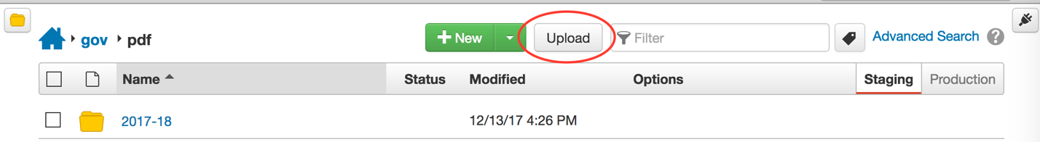
5. DRAG files from desktop or CLICK ADD to find the files on your desktop to select for upload. **Note:** RENAME the files to eliminate any spaces or other bad characters. We recommend using hyphens (-) ONLY to separate words. Be sure to include the .pdf, .docx or .pptx file extension if renaming.
6. CLICK Start Upload (blue button at bottom right) **Note:** You will be prompted that the upload was successful when done. ***You must now publish the files uploaded!***
7. CLICK the Check Box for each file(s) just uploaded and select PUBLISH.  
     
   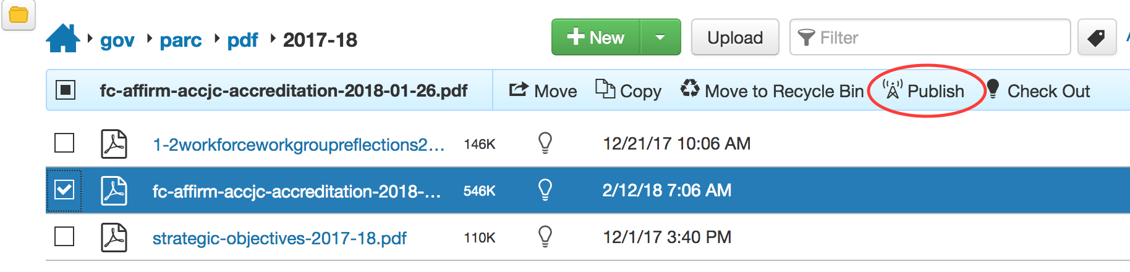
8. NAVIGATE back to the page where you want to create a link to the newly uploaded file(s) and follow steps for ADDING A LINK.