Community College District

Foothill-De Anza Community College District
Equal Employment Opportunity Plan

Approved by the Board of Trustees on June 10, 2019

Table of Contents

Purpose of EEO Plan 1

Plan Components ...........................................................................................................................
- Definitions 3
- Policy Statement. 5
- Delegation of Responsibility, Authority and Compliance 5
- Advisory Committee 8
- Complaints 9
- Notification to District Employees 13
- Training for Screening/Selection Committees 14
- Annual Written Notice to Community Organizations 15
- Analysis of District Workforce and Applicant Pools 16
- Analysis of Degree of Underrepresentation and Significant Underrepresentation 29
12. Methods to Address Underrepresentation 31
- Additional Steps to Remedy Significant Underrepresentation 32
- Additional Measures to Support Diversity and Ensure Equal Employment Opportunity 33
- Persons with Disabilities 34
- Graduate Assumption Program of Loans for Education 35
- Meeting Education Code Section 87482.6 36
- Community-based Organizations with a Commitment to Diversity 37

Purpose of the FHDA Equal Opportunity Plan
The Foothill-De Anza Community College District (District) Equal Employment Opportunity Plan (Plan), in compliance with Education Code section 87106(b) reflects the District's commitment to equal employment opportunity. In alignment with our belief that creating a working and academic environment which welcomes all, by fostering diversity and promoting excellence, this plan outlines our active and intentional steps to ensure equal employment opportunity. The Districts initial plan was adopted on May 2, 2016; later updated and renewed May 2019.

Education code section 87101 (a) indicates equal employment opportunity means "that all qualified individuals have a full and fair opportunity to compete for hiring and promotion and fully enjoy the benefits of employment by a community college district. Ensuring equal employment oppmiunity is advanced in an inclusive environment that fosters cooperation, acceptance, democracy, and the free expression of ideas. An inclusive environment is welcoming to men and women, persons with disabilities, individuals from all ethnic groups, and individuals from all other groups protected from discrimination by this article."

The District sees the value in creating an inclusive, equitable and innovative environment that meets the unique needs of our diverse students and employees.

Our District Equal Employment Opportunity Plan addresses:
  - CA Education Code, section 53003, Title 5, legal requirements
  - The District's plan to increase employee diversity; increase and sustain inclusion of underrepresented employees; and increase employee capacity to sustain such effo1is
  - Faculty and staff professional development opportunities regarding the contents of this
Plan

Definitions
Title 5, § 53001(a)-(p)J
- Adverse Impact: a statistical measure (such as those outlined in the EEO Commission's Uniform Guidelines on Employee Selection Procedures) that is applied to the effects of a selection procedure and demonstrates a disproportionate negative impact on any group protected from discrimination pursuant to Government Code section 12940. A disparity identified in a given selection process will not be considered to constitute adverse impact if the numbers involved are too small to permit a meaningful comparison.

- Diversity: means a condition of broad inclusion in an employment environment that offers equal employment opportunity for all persons. It requires both the presence, and the respectful treatment, of individuals from a wide range of ethnic, racial, age, national origin, religious, gender, sexual orientation, disability and socioeconomic backgrounds.

- Equal Employment Opportunity: means that all qualified individuals have a full and fair opportunity to compete for hiring and promotion and to enjoy the benefits of employment with the district. Equal employment opportunity should exist at all levels in the seven job categories which include executive/administrative/managerial, faculty and other instructional staff, professional non-faculty, secretarial/clerical, technical and paraprofessional, skilled crafts, and service and maintenance. Equal employment opportunity also involves:
- identifying and eliminating barriers to employment that are not job related; and
- creating an environment which fosters cooperation, acceptance, democracy, and free expression of ideas and is welcoming to men and women, persons with disabilities, and individuals from all ethnic and other groups protected from discrimination pursuant to Government Code section 12940.

- Equal Employment Opportunity Plan: a written document in which a district's workforce is analyzed and specific plans and procedures are set forth for ensuring equal employment oppo1iunity.

- Equal Employment Opportunity Programs: all the various methods by which equal employment opportunity is ensured. Such methods include, but are not limited to, using non­ discriminatory employment practices, actively recruiting, monitoring and taking additional steps consistent with the requirements of section 53006.

- Ethnic Group Identification: means an individual's identification in one or more of the ethnic groups reported to the Chancellor pursuant to section 53004. These groups shall be more specifically defined by the Chancellor consistent with state and federal law.

- In-house or Promotional Only Hiring: means that only existing district employees are allowed to apply for a position.

- Monitored Group: means those groups identified in section 53004(b) for which monitoring and reporting is required pursuant to section 53004(a).

- Person with a Disability: any person who (1) has a physical or mental impairment as defined in Government Code, section 12926, which limits one or more of such person's major life activities, (2) has a record of such an impairment, or (3) is regarded as having such an impairment. A person with a disability is "limited" if the condition makes the achievement of the major life activity difficult.

- Reasonable Accommodation: the efforts made on the part of the district in compliance with Government Code section 12926.

- Screening or Selection Procedures: any measure, combination of measures, or procedures used as a basis for any employment decision. Selection procedures include the full range of assessment techniques, including but not limited to traditional paper and pencil tests, performance tests, and physical, educational, and work experience requirements, interviews, and review of application forms.

- Significantly Underrepresented Group: any monitored group for which the percentage of persons from that group employed by the district in any job category listed in section 53004(a) is below eighty percent (80%) of the projected representation for that group in the job category in question.

Policy Statement
Title 5, § 53002
The Board supports the intent set forth by the California Legislature to assure that effort is made to build a community in which opportunity is equalized, and community colleges foster a climate of acceptance, with the inclusion of faculty and staff from a wide variety of backgrounds. It agrees that diversity in the academic environment fosters cultural awareness, mutual understanding and respect, harmony and respect, and suitable role models for all students. The Board therefore commits itself to promote the total realization of equal employment through a continuing equal employment opportunity program.

The Chancellor shall develop, for review and adoption by the Board, a plan for equal employment opportunity that complies with the Education Code and Title 5 requirements as from time to time modified or clarified by judicial interpretation.

Delegation of Responsibility, Authority and Compliance

[Plan Requirement- Title 5, §§ 53003(c)(l) and 53020]
It is the goal of the Foothill-De Anza Community College District that all employees promote and support equal employment opportunity because equal employment opportunity requires a commitment and a contribution from every segment of the district. The general responsibilities for the prompt and effective implementation of this Plan are set forth below.

Governing Board: The governing board is ultimately responsible for proper implementation of the district's Plan at all levels of district and college operation, and for ensuring equal employment opportunity as described in the Plan.

Chancellor and Vice Chancellor of Human Resources/Equal Opportunity: The governing board delegates to the Chancellor and Vice Chancellor of Human Resources/Equal Opportunity the responsibility for ongoing implementation of the Plan and for providing leadership in supporting the district's equal employment opportunity policies and procedures. The Chancellor and Vice Chancellor shall advise the governing board concerning statewide policy emanating from the Board of Governors of the California Community Colleges and direct the publication of an annual report on Plan implementation. The Chancellor shall evaluate the performance of all administrative staff who report directly to the Chancellor on their ability to follow and implement the Plan.

Equal Employment Opportunity Officer: The district has designated the Director of Equity, Employment and Professional Development as the District's Equal Employment Opportunity Officer. The Director is responsible for the day-to-day implementation of the Plan. If the designation of the equal employment opportunity officer changes before this Plan is next

revised, the district will notify employees and applicants for employment of the new designee. The equal employment opportunity officer is responsible for administering, implementing and monitoring the Plan and for assuring compliance with the requirements of Title 5, sections 53000 et seq. The equal employment opportunity officer is also responsible for receiving complaints described in Plan Component 6 and for ensuring that applicant pools and selection procedures are properly monitored.

District Diversity and Equity Advisory Committee: The District has established the District Diversity and Equity Advisory Committee (DDEAC) to act as an advisory body to the equal employment opportunity officer and the district as a whole to promote understanding and support of equal employment opportunity policies and procedures. The DDEAC shall assist in the implementation of the Plan in conformance with state and federal regulations and guidelines, monitor equal employment opportunity progress, and provide suggestions for Plan revisions as appropriate.

Agents of the District: Any organization or individual, whether or not an employee of the district, who acts on behalf of the governing board with regard to the recruitment and screening of personnel, is an agent of the District and is subject to all the requirements of this Plan.

Good Faith Effort: The district shall make a continuous good faith effort to comply with all the requirements of its Plan.

Legal Authority
California community colleges are mandated by the California Code of Regulations Title 5, section 53003(a); and the California Education Code, section 87100 to develop and implement an Equal Employment Opportunity Plan.

California Code of Regulations Title 5, Section 53003(A)-District Plan
The governing board of each community college district shall develop and adopt a district-wide written equal employment opportunity plan to implement its equal employment opportunity program. Such plans shall be submitted to the Chancellor's Office. The Chancellor's Office retains the authority to review district plans on a case-by-case basis.

California Education Code, Section 87100-Legislative Finds and Declarations:
- The Legislature finds and declares all of the following:
I) In fulfilling its mission within California's system of public higher education, the California community colleges are committed to academic excellence and to providing all students with the opportunity to succeed in their chosen educational pursuits.

- Academic excellence can best be sustained in a climate of acceptance and with the inclusion of persons from a wide variety of backgrounds and preparations to provide service to an increasingly diverse student population.
- A workforce that is continually responsive to the needs of a diverse student population may be achieved by ensuring that all persons receive an equal opportunity to compete for employment and promotion within the community college districts and by eliminating barriers to equal employment oppmiunity.
- It is the intent of the Legislature to establish and maintain within the California community college districts a policy of equal opportunity in employment for all persons, and to prohibit discrimination or preferential treatment based on ethnic group identification, or on any basis listed in subdivision (a) of section 12940 of the Government Code, as those bases are defined in sections 12926 and 12926.1 of the Government Code, except as otherwise provided in section of 12940 of the Government Code. Every aspect of personnel policy and practice in the community college districts should advance the realization of inclusion through a continuing program of equal employment opportunity.
- The Legislature recognizes that it is not enough to proclaim that community college districts must not discriminate and must not grant preferential treatment on impermissible bases. The Legislature declares that efforts must also be made to build a community in which nondiscrimination and equal opportunity are realized. It is the intent of the Legislature to require community college districts to adopt and implement programs and plans for ensuring equal employment opportunity in their employment practices.

Title 5, Section 53026 Complaints-Violation of Equal Employment Opportunity Regulations
Each community college district shall establish a process permitting any person to file a
complaint alleging that the requirements of this subchapter have been violated. A copy of the complaint shall immediately be forwarded to the Chancellor, who may require that the district provide a written investigative report within ninety (90) days. Complaints that also allege discrimination prohibited by Government Code sections 11135 et seq. shall be processed according to the procedures set forth in subchapter 5 (commencing with section 59300) of Chapter 10 of this division.

Advisory Committee
Title 5, Section 53305 - Advisory Committee "Each community college district shall establish an Equal Employment Opportunity Advisory Committee to assist the district in developing and implementing the plan required under section 53003. This advisory committee shall include a diverse membership whenever possible."

In addition to implementing the Equal Employment Opportunity plan for the District, the District Diversity and Equity Advisory Committee (DDEAC) is responsible for developing, implementing and coordinating district-wide diversity training, plans and activities that promote equal employment opportunity, nondiscrimination, retention and diversity. The committee may also assist in promoting an understanding and support of equal opportunity and nondiscrimination policies and procedures. The DDEAC receives reports from both the De Anza Equity Action Committee and the Foothill Equity Action Council. The DDEAC disburses the Equal Employment Opportunity fund allocation, implements appropriate sections of the State Chancellor's Equity and Diversity Task Force Report and completes other required reports.

The Equal Employment Opportunity Officer shall train the advisory committee on:
- the requirements of Section 53003 of article 1, of subchapter 1, of chapter 4, of division 6, of Title 5, and of state and federal nondiscrimination laws
- identification and elimination of bias in hiring
- the educational benefits of workforce diversity and
- the role of the advisory committee in carrying out the District's EEO Plan

The committee shall include a diverse membership whenever possible, including the following members:
  - Director of Equity, Employment and Professional Development, Chair
  - Central Services (Two members)
  - Faculty Association (One member)
  - Association of Classified Employees (One member)
  - Teamsters (One member)
  - Classified School Employees Association (One member)
  - AMA (One member)
  - Deans of Equity (One from each college)
  - Students representatives (One from each college)1

1 Students from marginalized student groups sought and encouraged to participate as DDEAC member.

Complaints Alleging Violation of the Equal Employment Opportunity Regulations
[Plan Requirement - Title 5, §§ 53003(c)(2), 53026 and 59300 et seq.]
Complaints Alleging Violation of the Equal Employment Opportunity Regulations (Section 53026):
From Board Policy 4100: "The Foothill-De Anza Community College District Board of Trustees values the contributions that a culturally diverse community of faculty, staff, and administrators makes to all the students who study at Foothill and De Anza Colleges. The Board of Trustees desires for students and for all district employees an environment where diverse cultures, abilities, and needs are respected and where difference offers stimulating opportunities for learning and personal fulfillment. Therefore, the Board commits itself to develop policies and procedures and to act in such ways as to encourage a positive, harmonious work and learning environment.

With the intent to realize its commitments, the Board of Trustees supports equality in employment and educational opportunity. The Board believes that effective recruitment and hiring of a diverse faculty and staff and a vigorous outreach effort to recruit a similarly diverse student population are, along with appropriate support services, impo1iant means to cultural diversification of the college community and to the enrollment, retention, and transfer of all students.

The Board directs the Chancellor and the college presidents to assume responsibility for implementing and communicating the Board's policy and commitment. Every department, division, or organizational unit head shall be responsible for the proper and effective implementation of the District Cultural Diversity/Equal Opportunity Policy. The Board requires that the district administrative staff and all agents acting on the Board's behalf make every effort to ensure that the recruitment, screening, selection, hiring, and promotional processes for all employment positions are in accordance with the principles of equal opportunity. Additionally, in keeping with support for student success, the Board directs that the principles and spirit of this Cultural Diversity/Equal Opportunity Policy be applied to student admissions and enrollment, financial aid, transfer, curriculum, and faculty and staff development."

Any person who believes they are the recipient of an equal employment opportunity regulation violation or who has witnessed a violation against another individual may file a written report. The report shall include the names of the individuals involved, the date(s) of the event(s) at issue, and a detailed description of the actions constituting the alleged violation, and shall be signed and dated by the reporting party.

A repmi regarding a hiring process must be filed no later than sixty (60) days after the date of the alleged violation or 60 days after the reporting party knew or should have known of the

violation. In any case, a report shall be deemed not timely if it is filed more than twelve months following the alleged violation.

A request for exception to the timeline may be made to the EO Officer and shall include a description of the extenuating circumstances that serve as the basis for the request.

Complaints Alleging Unlawful Discrimination or Harassment (Section 59300 et seq.): "It is the Policy of the Foothill-De Anza Community College District to provide an educational and employment environment free of unlawful harassment and discrimination. The Board shall not discriminate against any person in the provision of any program or service based on ethnic group identification, race, religion, color, national origin, ancestry, physical disability, mental disability, medical condition, marital status, sex or gender, age, sexual orientation, or any other legally protected status, or on the basis of these perceived characteristics or based on association with a person or group with one or more of these actual or perceived characteristics. Anyone who engages in unlawful harassment or discrimination shall be subject to sanctions up to and including termination of employment or expulsion in accordance with applicable contractual, procedural and statutory requirements ."

Reports of Unlawful Discrimination, Harassment or Retaliation Reports not involving criminal proceedings may be filed as follows: (Please note, the official procedure and complete information is located at http://hr.fhda.edu/ downloads/BP%204640.pdf )
- By contacting a Title 5 Coordinator/Officer directly. See Title 5 Coordinators listed below.
- By submitting a complaint on an Unlawful Discrimination Complaint Form that specifies that you wish to file a Formal Complaint. You are encouraged, but not required, to use this fonn: http://hr.fhda.edu/ downloads/UnlawfulDiscrimForm Rev Nov%202018. pdf

Unlawful Discrimination, Harassment or Retaliation complaints that initiate criminal proceedings may be filed:
- By notifying the Foothill-De Anza Police Department
- By notifying law enforcement where the incident occurred

Note: Law enforcement agencies do not automatically notify campus authorities.

Title 5 Coordinator - Campus and Central Services
The Title 5 Coordinator oversees compliance with all aspects of the Unlawful Discrimination, Harassment and Retaliation Policy. The Title 5 Coordinator has the authority to enact interim measures to prevent additional allegations and protect both parties.

De Anza College: Dean of Student Development and EOPS, 21250 Stevens Creek Boulevard, Cupertino, CA 95014, (408) 864-8828;

Foothill College: Dean of Student Affairs and Activities, 12345 El Monte Road, Los Altos Hills, CA 94022, (650) 949-7241;

Central Services: Director of Equity, Employment, and Professional Development, 12345 El Monte Road, Los Altos Hills, CA 94022, (650) 949-6210.

District Title 5 Officer
The District also has a Title 5 Officer. The District Title 5 Officer is the Vice Chancellor of Human Resource/Equal Opportunity, District Office of Human Resources, 12345 El Monte Road, Los Altos Hills, CA 94022, (650) 949-6210. The District Title 5 Officer is responsible for overseeing Title 5 compliance for the District as a whole.

Resolution Procedures
There are two types of resolution procedures available within the District/Campus procedures: Informal Resolution Procedure and Formal Resolution Procedure. In addition to these internal procedures, a reporting party may also file a complaint with the Department of Fair Employment and Housing (DFEH), the Office of Civil Rights (OCR) or with the Equal Employment Opportunity Commission (EEOC) for a complaint within their jurisdiction.

Informal Resolution
An Informal Resolution Procedure is a process that a Reporting Party undertakes with the appropriate campus or central services Title 5 Coordinator in an attempt to reach a resolution that is acceptable to both the Reporting Party and the Respondent. The Title 5 Coordinator does not make a determination as to whether a Respondent has violated District policy. Instead, the Title 5 Coordinator attempts to facilitate a mutually acceptable resolution, which may include conflict resolution techniques, mediation, or investigation.

If the parties agree to a proposed resolution that does not include disciplinary action, the resolution shall be implemented and the informal process shall be concluded.

Formal Resolution
A Formal Resolution Procedure includes an official determination as to whether a Respondent(s) has violated the District's policy on Unlawful Discrimination, Harassment and Retaliation. A Formal Resolution Procedure typically includes:
- Filing a written report
- A meeting with the campus or central services Title 5 Coordinator or the District Title 5 Officer (or their designee)

- An assessment of necessary Interim/Remedial Measures
- Investigation
- Administrative Determination
- Notification of outcome to both Respondent and Reporting Party
- Appeal rights (if any)
- Notification of outcome sent to appropriate District, State and/or Federal agencies

To request a Formal Resolution, a reporting party may file a report in one of the following three ways:

- Reporting Parties are encouraged but not required to use the Unlawful Discrimination Complaint Form that is linked here: http://hr.fhda.edu/ forms.html

- Reporting Parties may also provide report in another written form providing the report specifies that the report is a Formal Complaint of Discrimination, Harassment or Retaliation.

- An alternate approved complaint form can also be obtained from the State Chancellor' s Web site, which can be accessed here: http://extranet.cccco.edu/Divisions/Legal/Discrimination.aspx

Notification to District Employees
[Title 5, § 53003(c)(3)]
The commitment of the governing board and the Chancellor to equal employment opportunity is emphasized through the broad dissemination of its Equal Employment Opportunity Policy Statement and the Plan. The policy statement will be printed in the college catalogs and class schedules. The Plan and subsequent revisions will be distributed to the district's governing board, the Chancellor, Presidents, administrators, the academic senate leadership, union representatives and members of the District Diversity and Equity Advisory Committee. The Plan will be available on the district's website, and when appropriate, may be distributed by email.
Each year, the district office will provide all employees with a copy of the board's Equal Employment Opportunity Policy Statement (located in Plan Component 3 of this Plan) and written notice summarizing the provisions of the district's Equal Employment Opportunity Plan. The Human Resources Department will provide all new employees with a copy of the written notice described above when they commence their employment with the district. The annual notice will contain the following provisions:

  - The importance of the employee's participation and responsibility in ensuring the Plan's
implementation.

  - Information about where the plan is located, including, but not limited to the campus and district websites, the Office of the Chancellor, the offices of the Title 5 Coordinators for each of the colleges and Central Services, and the District Office of Human Resources.

Training for Search/Selection Committees
[Plan Requirement - Title 5, § 53003(c)(4)]
Any organization or individual, whether or not an employee of the district, who is involved in the recruitment and screening/selection of personnel shall receive appropriate training on
- the requirements of the Title 5 regulations on equal employment opp01iunity (section 53000 et. seq.);
- the requirements of federal and state nondiscrimination laws;
- the requirements of the district's Equal Employment Opportunity Plan;
- the district's policies on nondiscrimination, recruitment, and hiring;
- principles of diversity and cultural proficiency;
e the educational benefits and value of a diverse workforce;
- the elimination of bias in hiring decisions; and
o best practices in serving on a selection or screening committee.

Persons serving on a Search or Selection Committee will be required to have completed training within the 24 months prior to service. This training is mandatory; individuals who have not received this training may not serve until such training is completed. The Equal Employment Oppmiunity Officer is responsible to assure the required training is offered on a regular basis.
Any individual, whether or not an employee of the district, acting on behalf of the district with regard to recruitment and screening of employees is subject to this requirement, the equal employment opportunity requirements of Title 5 and the district's Equal Employment Opportunity Plan.

Annual Written Notice to Community Organizations

[Plan Requirement - Title 5, § 53003(c)(5)]
The Equal Employment Opportunity Officer will provide annual written notice to appropriate community-based and professional organizations concerning the Plan. The notice will inform these organizations that they may obtain a copy of the Plan, and shall solicit their assistance in identifying diverse qualified candidates. The notice will include a summary of the Plan. The notice will also include the internet address where the district advertises its job openings, the positions and departments and phone numbers of individuals to call in order to obtain employment information. The district will actively seek to reach those institutions, organizations, and agencies that may be recruitment sources. A list of organizations, which will receive this notice, is attached to this Plan. This list may be revised from time to time as necessary.

Analysis of District Workforce and Applicant Pools

[Plan Requirement- Title 5, § 53003(c)(6)]
The District Office of Human Resources will annually review the district's workforce composition and shall monitor applicants for employment on an ongoing basis to evaluate the District's progress in implementing the Plan, to provide data needed for the reports required by this Plan.. and to determine whether any monitored group is underrepresented. Monitored groups are women, American Indians/Alaskan Natives, Asians or Pacific Islanders, Blacks/African­ Americans, Hispanics/Latinos.

For reporting purposes, each applicant will be afforded the opportunity to voluntarily identify gender identity, ethnic group identification and, if applicable, disability. Persons may designate as many ethnicities as they identify with, but shall be counted in only one ethnic group for reporting purposes. This information will be kept confidential and will be separated from the applications that are forwarded to the search/selection committee and hiring administrator(s).
Reporting will be done for each college in the district. The district shall also report to the Chancellor the results of its annual study of employees. At least every three years the Plan will be reviewed and, if necessary, revised based on an analysis of the ethnic group identification, gender, and disability composition2 of existing staff and of those who have applied for employment in each of the following identified job categories:
- Administrative
  - Executive3
  - Educational
  - Program
- Faculty
  - 10 months
  - 11-12 months
- Classified
  - ACE
  - ACE Hourly
C. CSEA
- Teamsters
- Police Officers

The district's 2016-17 and 2017-18 applicant and workforce pools follow.

2 If applicable to data sets.
3 Executive and program included in applicant analysis.

2016-17 Race E-Class
Adm inist r ato■
Candidates - Race (group) ■Classi fied
Requisitions - American Asian Black or Choose Hispanic Native Two or Grand ■Facul ty
■
E-Class E-class Indian or.. (not His.. African.. Not to Di.. Filipino or Latino Hawaiia.. More Ra.. White Total Gra nd Tot al Administrator A1 Administ rati. 2 2
A7 Ari minist r at i.. 2 52 37 so 7 30 5 108 291
A3 Admini st r ati .. 3 bl 64 / 9 1 0 ? 9 1 4 429
Classified Cl Cl assi fied-AC[ 9 8:<l ?Cl !,74 1(,1 711 l>9 3 9G4 3,585
CZ Cl assi fied-AC.. 22 2 13 4 9 10 60 I
r. CI.Jssi fi ed CS .. 1 27 ,n 5/ 11 127 2 78 346
C4 Cl assi fied Te.. 70 1'1 l, ,1 7"-l ,1 4.-] 126
CS Cl assi fied- Co . . 4 I. J 1 14 8 34
CG Classified-Po .. 5 2 2 1 12 4 26
Faculty Fl Faculty 10 111.. 9 201 so 185 9 79 6 1 421 961
F2 Faculty 11 to .. I <)(-. 48 ff{ 1 / 64 -l 11F? 4 6 1
F3 Facul t y-CDC .. 1 1
Grand Total 31 1,325 530 1,064 225 1,121 98 4 1,924 6,322

2016-17 Gender
Candidates - Gender (group)
E·Class Requisitions· E-class Choose Not to Disclose Female Male Gr and Total Administrator A1 Administ r at ive+ xew t .. 7 2
A? Administ rat ive Fdu Cilt .. 75 117 J S4 291
A3 Administ rative -Progra .. 41 179 209 429
Total 68 291 363 722
Classified Cl Cl ass i fi ed-ACE 2 2,,'5 1,0:s 3,585
CZ Classi fi ed-ACE Hou r ly fl l.7 2 60 I
;>/'II
C3 Cl assi fied·CSc A ,v l'l 346
C4 Class i fied Teamsters I l>l r;; 1 26
CS Cl assi fied Conf idential 1 zi:; !, 34
C6 Clas si fied-Po lice Office.. 2 4 20 26
Tota l 354 2, 07 1,416 4,177
Facult y ri racuIt y-10 months 70 452 439 961
17 1 arn l t y-11 to 12 months 41 ?8? 118 461 1 F3 Fu cult y rnc Teacher s 1 1
Total 112 734 577 1,423
Grand Total 534 3,432 2,356 ,6 322

2017-18 Race

E-Cl as s
Administrato r
■
■
Candidates - Race Cl assifi ed
■
r aculty
■
E-Class Administrator | Requisitions  - E-class  Al /\dminis.. | Choose  Notto D..  1 | American  Indian a.. | Asian (not His.. | Black or African .. | Filipino | Hispanic or Latino | Native Ha Two or  waiian.. More Ra.. |  | White | Grand Total  1
 | A? Adminis.. | 79 |  | 44 | 71 | s | 44 | 6 |  | 156 | 405 _{t}
 | A3Adminis.. | 69 | 2 | 42 | &6 | 6 | 55 | 9 |  | 136 | 385 :
Classified | Cl Cl assifi e.. | 40? | 10 | 521 | 138 | 71 | lll4 | l6 |  | ,ZS | 2,087
 | C? Classifie.. | 21 | 1 | ?[, | (., |  | 14 | 1 |  | 2,1 | 98
 | C3 Class ifi e.. | ;>O | ? | 18 | r, | JO | 1,4 | ? |  | 2(, | 1481
 |  |  |  |  |  | !l | 17 | ,1 |  | ?7 | 126
CS Cl assifi e.. 1,1 1 lJ ' 1'1 |  |  |  |  |  |  |  | 2 |  | lB | 106 I
 | CG Cl assifie .. |  |  | 1 |  |  |  |  |  |  | 1 '
Faculty | Fl r acul ty- .. | % | l | 115 | 3? | 13 | 49 | 2 | 1 | 157 | 465
 | rz f'aculty . | 19 |  | ?b | 14 | 4 | S? | l |  | ,17 | I  160
Grand Tota l |  | 749 | 17 | 847 | 349 | 125 | 698 | 65 | 1 | 1,131 | 3,982

Gr and Tota l

(4 Classifie.. ?'l
,l,!, b

2017 -18 Gender
Candidates - Gender (group)
E-Class Requ i sitio n E-class I Choose Not to Disclose Fe male Male Grand Total1
Administ ra.. /\1 Administrative l: xecut . . 1 1
AZ Administrative-Educat.. 62 167 176 405
A3 J\dminist r ative-Progra.. 55 150 180 385
Tota l 118 317 356 791
Classified C1 Classifi ed-ACE ;t'l l l !', t) ' 1 2,087
CZ Classified -ACE I lourly 1S so n , 98

C3 Cl assi fi ed-CS FA 1, 1 (
 | C4 Classified-Teamsters  CS Classifi ed Confidential | lG  n | ; c· | 1, 1 | 126  106 I
 | C6 Cl assi fi ed-Police Office.. |  |  | 1 , | 1
 | l otal | 429 | 1,367 | 770 | 2,5661
Faculty | fl raculty-10 months | 73 | 206 | 186 ' | 465
 | F2 Facull y-1 1 lo 1 2 months | 11 | 100 | 49 | 160
 | Tota l | 84 | 306 | 235 | 625
Grand Total |  | 631 | 1,990 | 1,361 | 3,9 82 1

llb4.Si
1481

Fall 2018 FHDA Total District Employee Demographics4

Fall 2018 FHDA Employee Demographics by Gender

Classified 237

PT Faculty 374
Educational
Administrator 28
1
Educational Administrator 52
Tenured/Tenure­ track Faculty 25
Tenured/Tenure­ track Faculty 194
Classified 335 PT Faculty 493

4 District-wide data from CCCCO Data Mart does not in clud e executiv e and program administrators.

Fall 2018 FHDA Classified Employees
African-American American
20 Indian/Alaskan Native
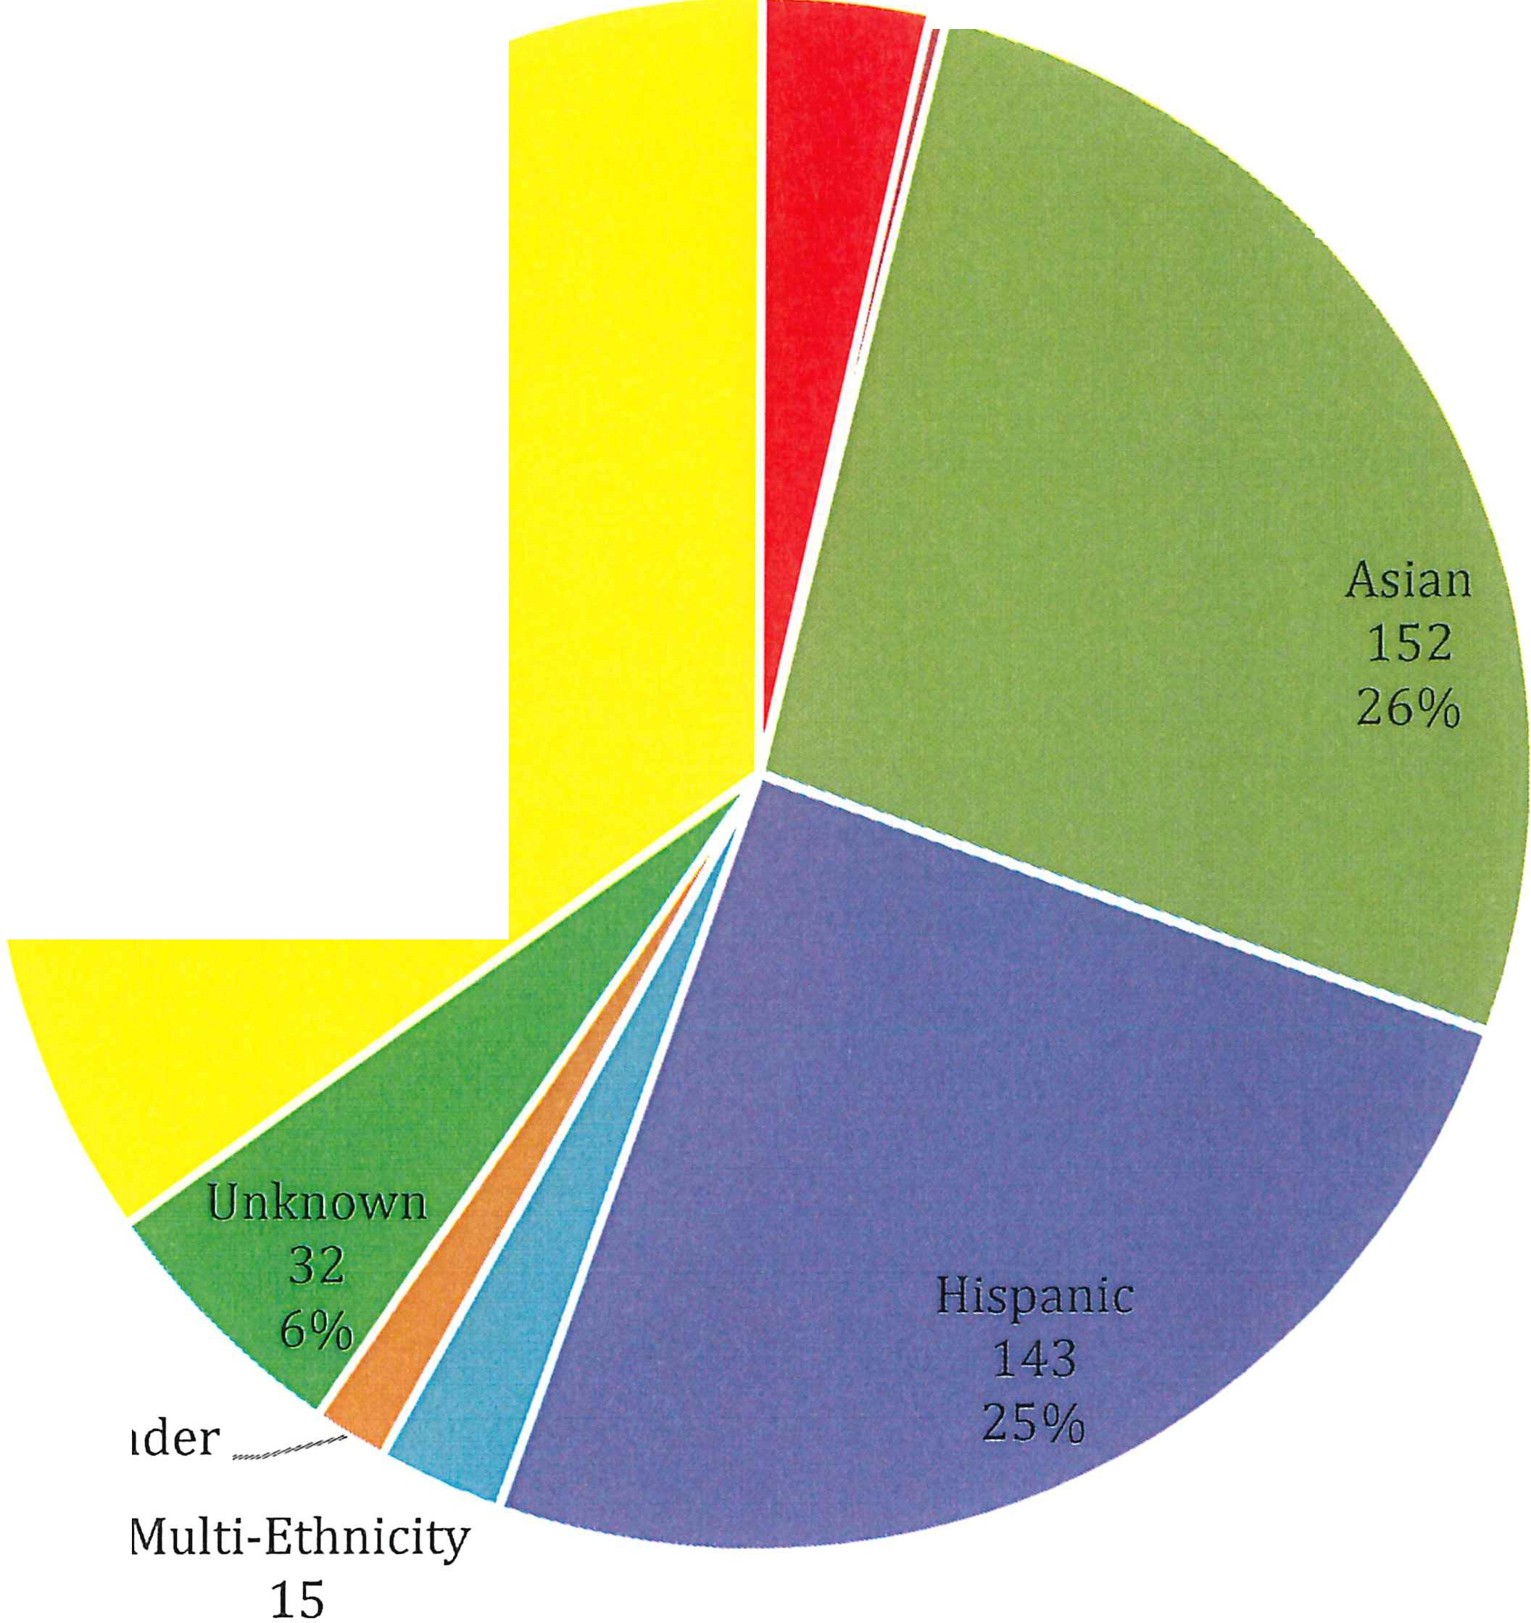3% / 2
. 0%

White Non-Hispanic
199
35%

Pacific Islander -
9
2%
3%

African-American
24
American Indian/Alaskan Native
9

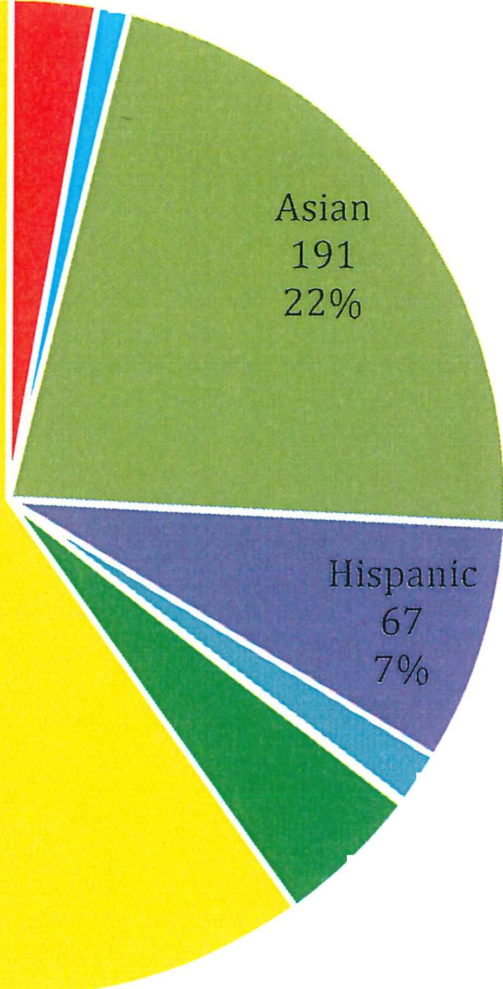3% -
r 1%

White Non-Hispanic
519
60%

------ Multi- hnicity

Fall 2018 FHDA Part-time Faculty

2%
\ Pacific Islander l unknow n 1
41 0%
5%
--

African-American
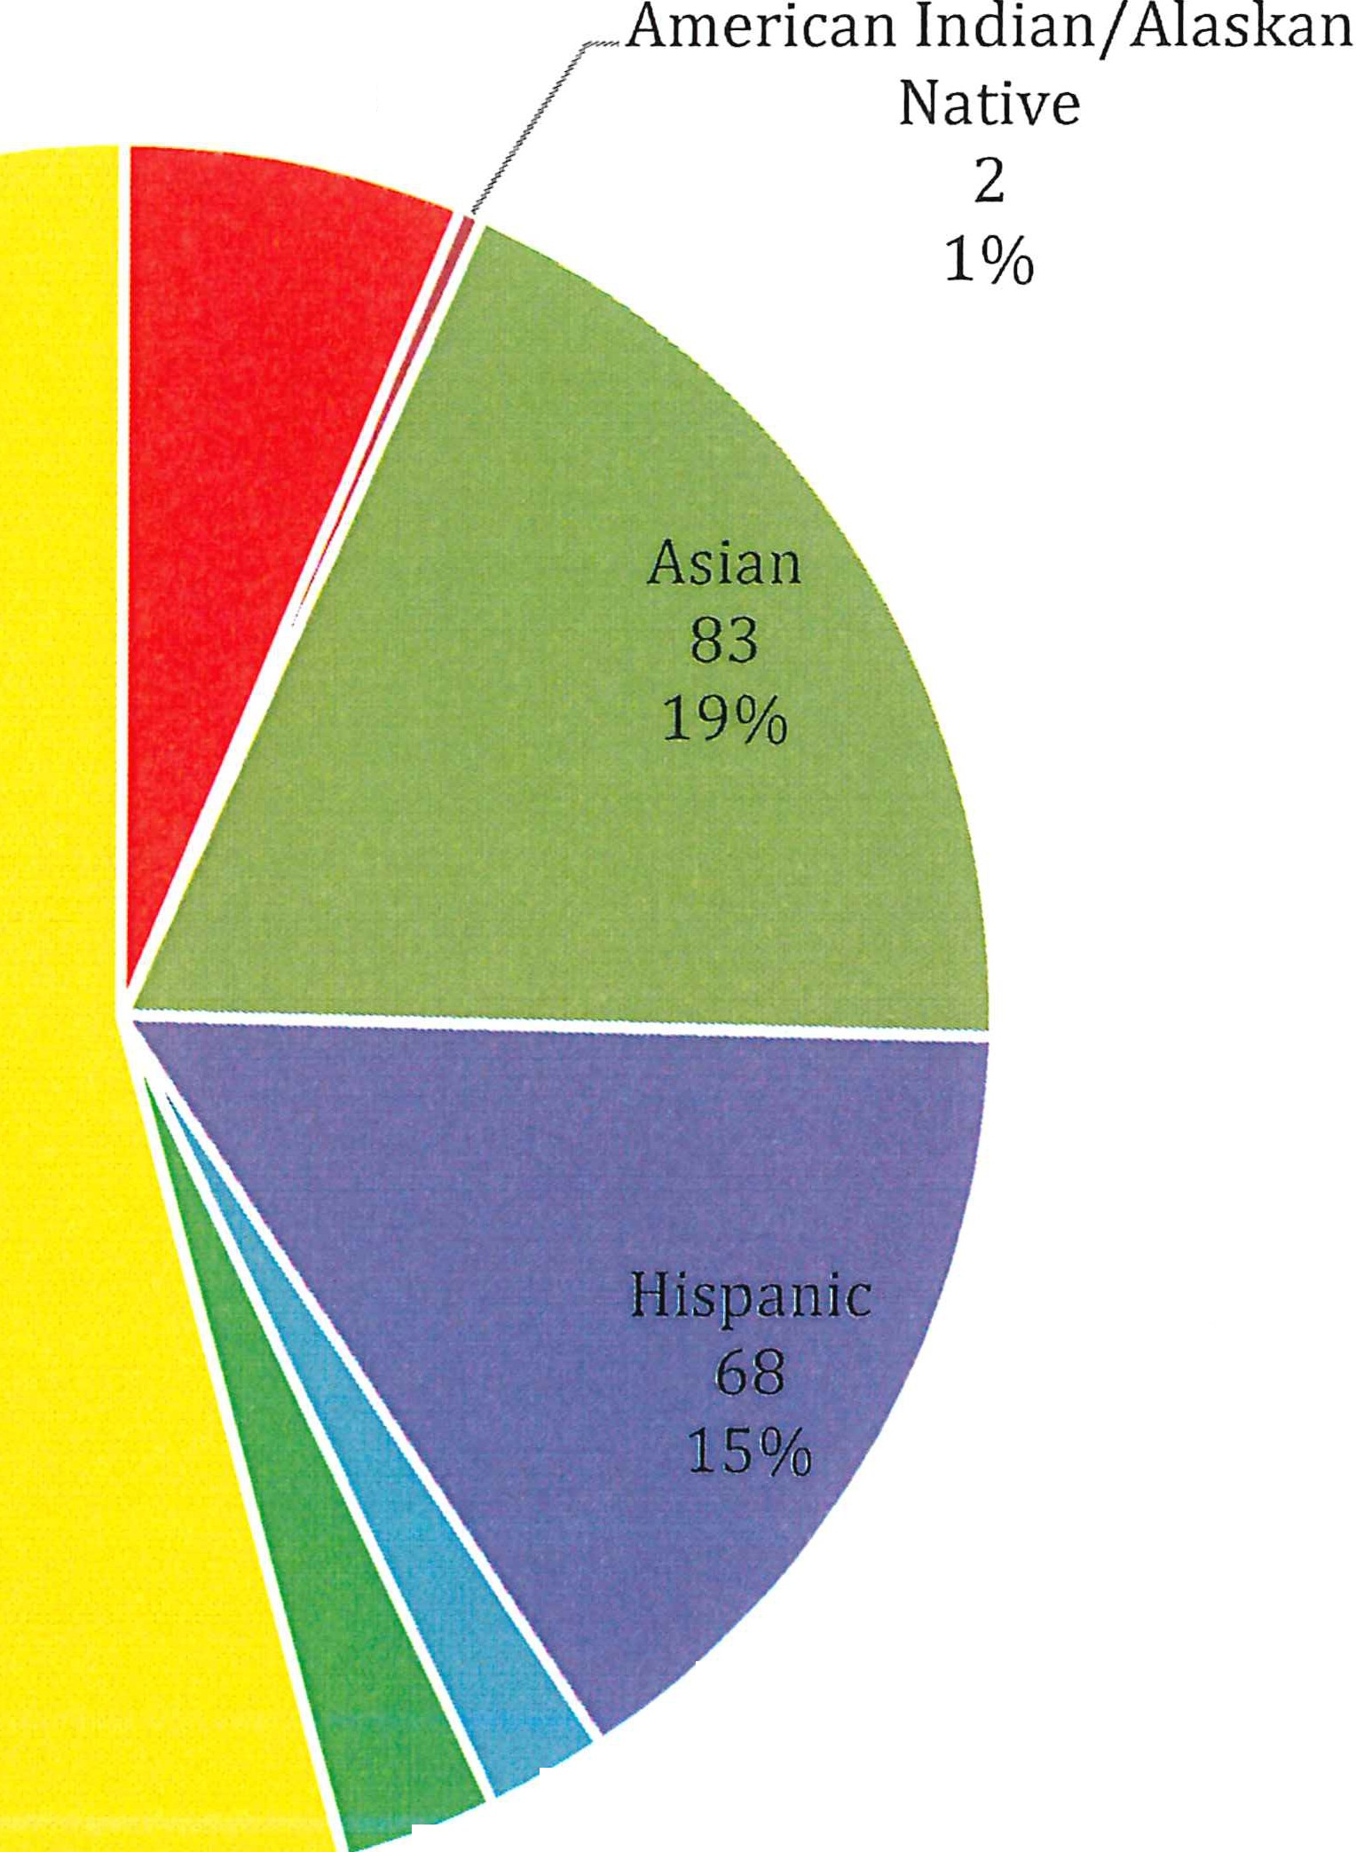
28
6%

White Non-Hispanic
241
54%

Fall 2018 FHDA Tenured/Tenure-track Faculty
----- Multi-Ethnicity
\_ Unknown 10
13 2%
3%

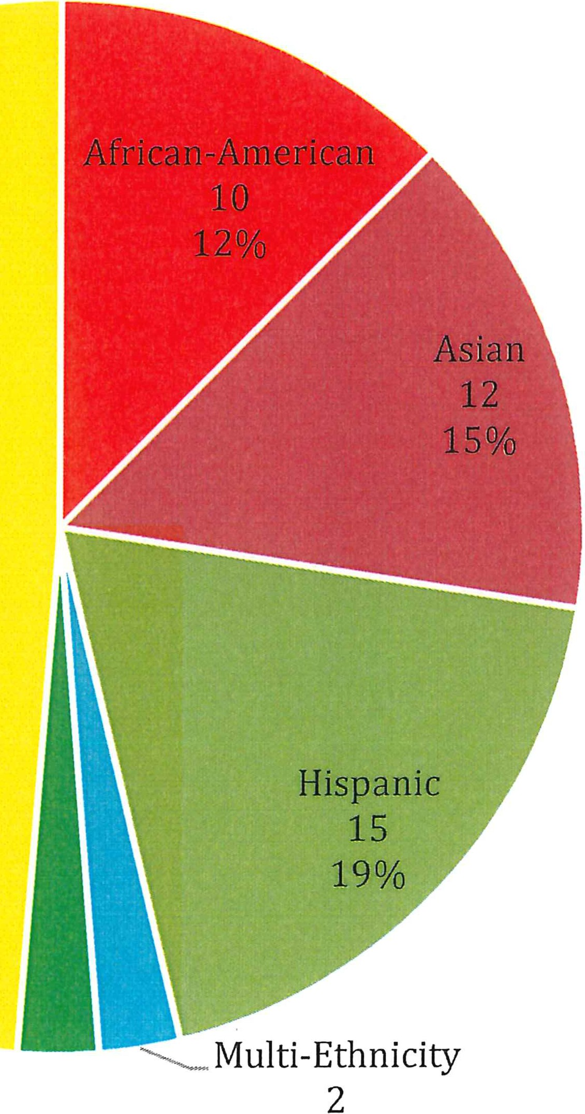
Fall 2018 FHDA Educational Administrators

White Non-Hispanic
39
49%

Unknow n _-
2
3% 2%

2018 Data by College Campus

Foothill College (CCCCO Data Mart)

Fall 2018 Foothill Employee Demographics by Gender Count741

Male Female
Educationa l Admin. 9 Educational Admin . 21
Full-t ime Fa culty. 75 Full-time Faculty. 104
Part -time. 236

Pa rt-time. 172
Classified. 39
Classi fied. 85

Fall 2018 Foothill Educational Administrators

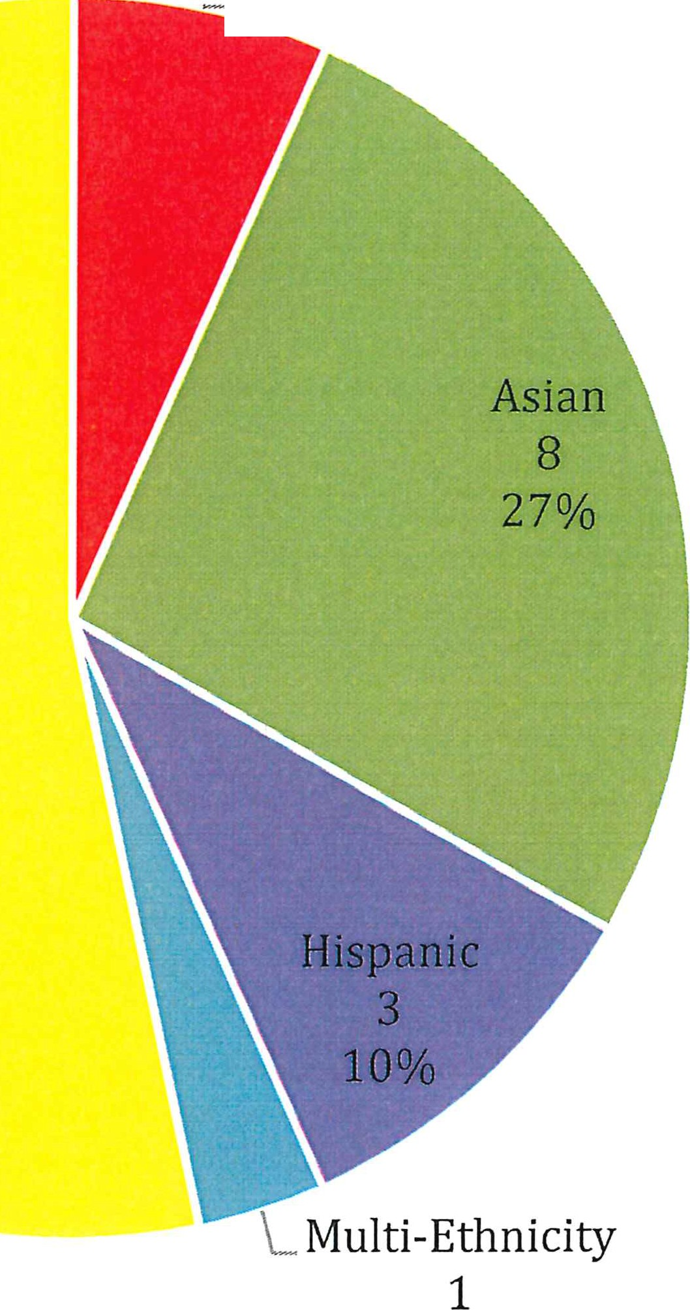- - - - African -Ame rican
=-- - - - - - - -
--
2
7%

White Non-His pan ic 16

3%

Fall 2018 Foothill Academic Tenure/Tenure-track Faculty

African-American
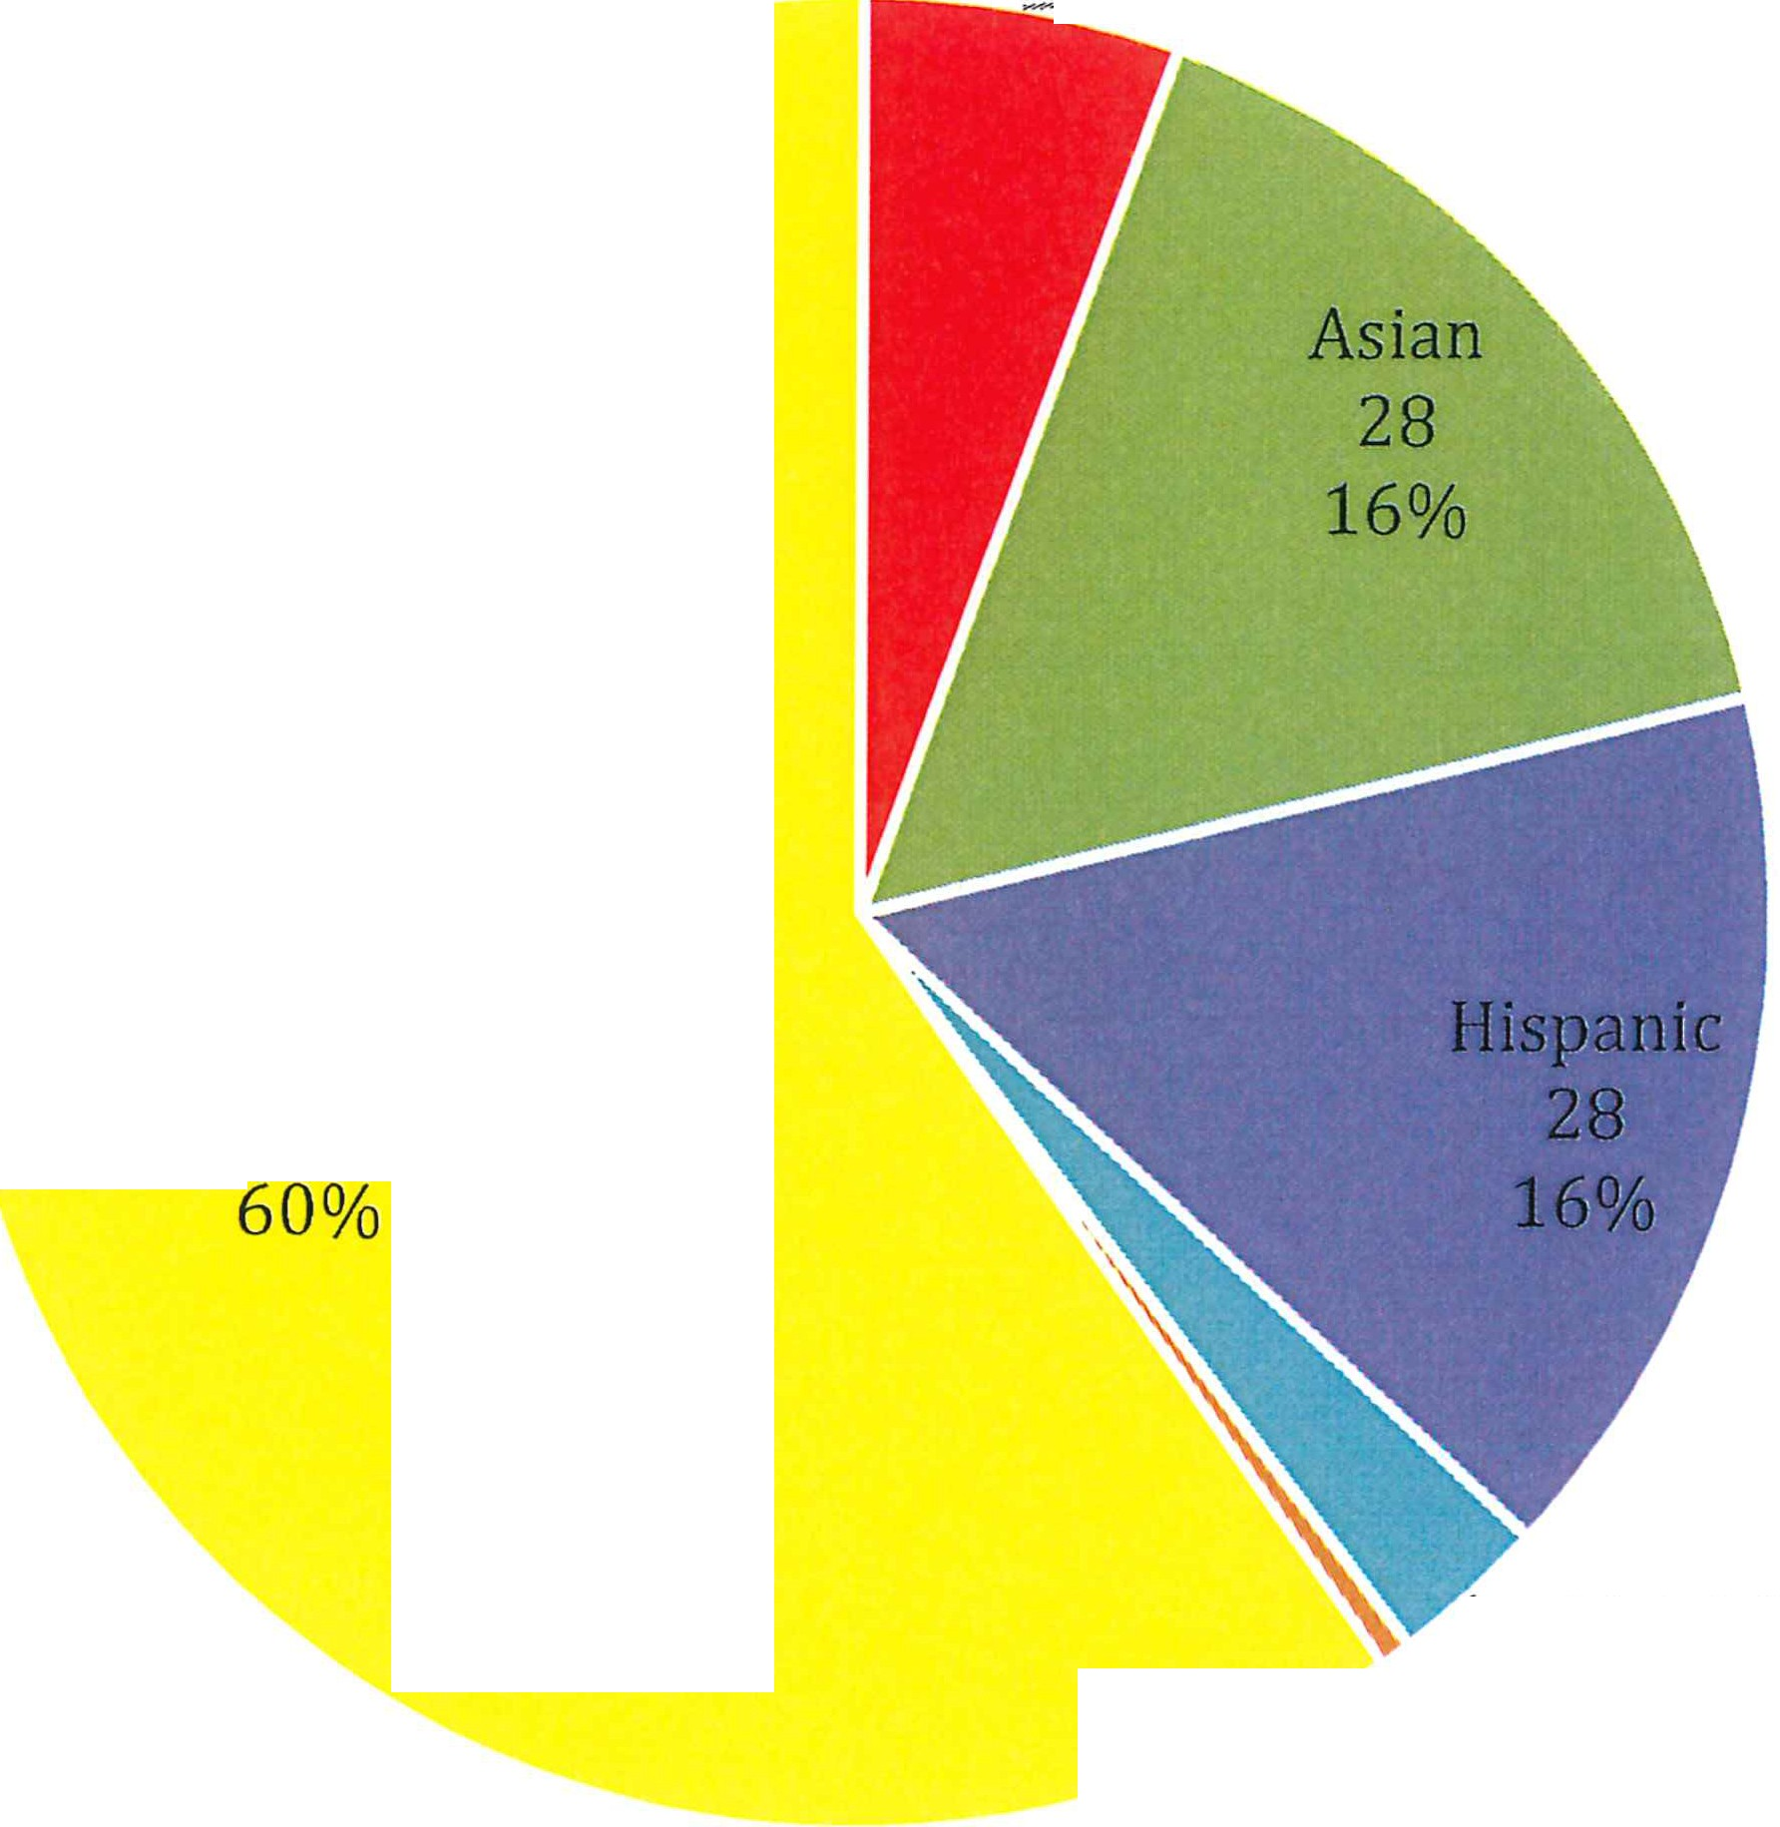
------ 10
5%

White Non-Hispanic
107

"'-. Multi-Ethnicity Unknown 5
1 3%
0%

Fall 2018 Foothill Part-time Faculty

African-American
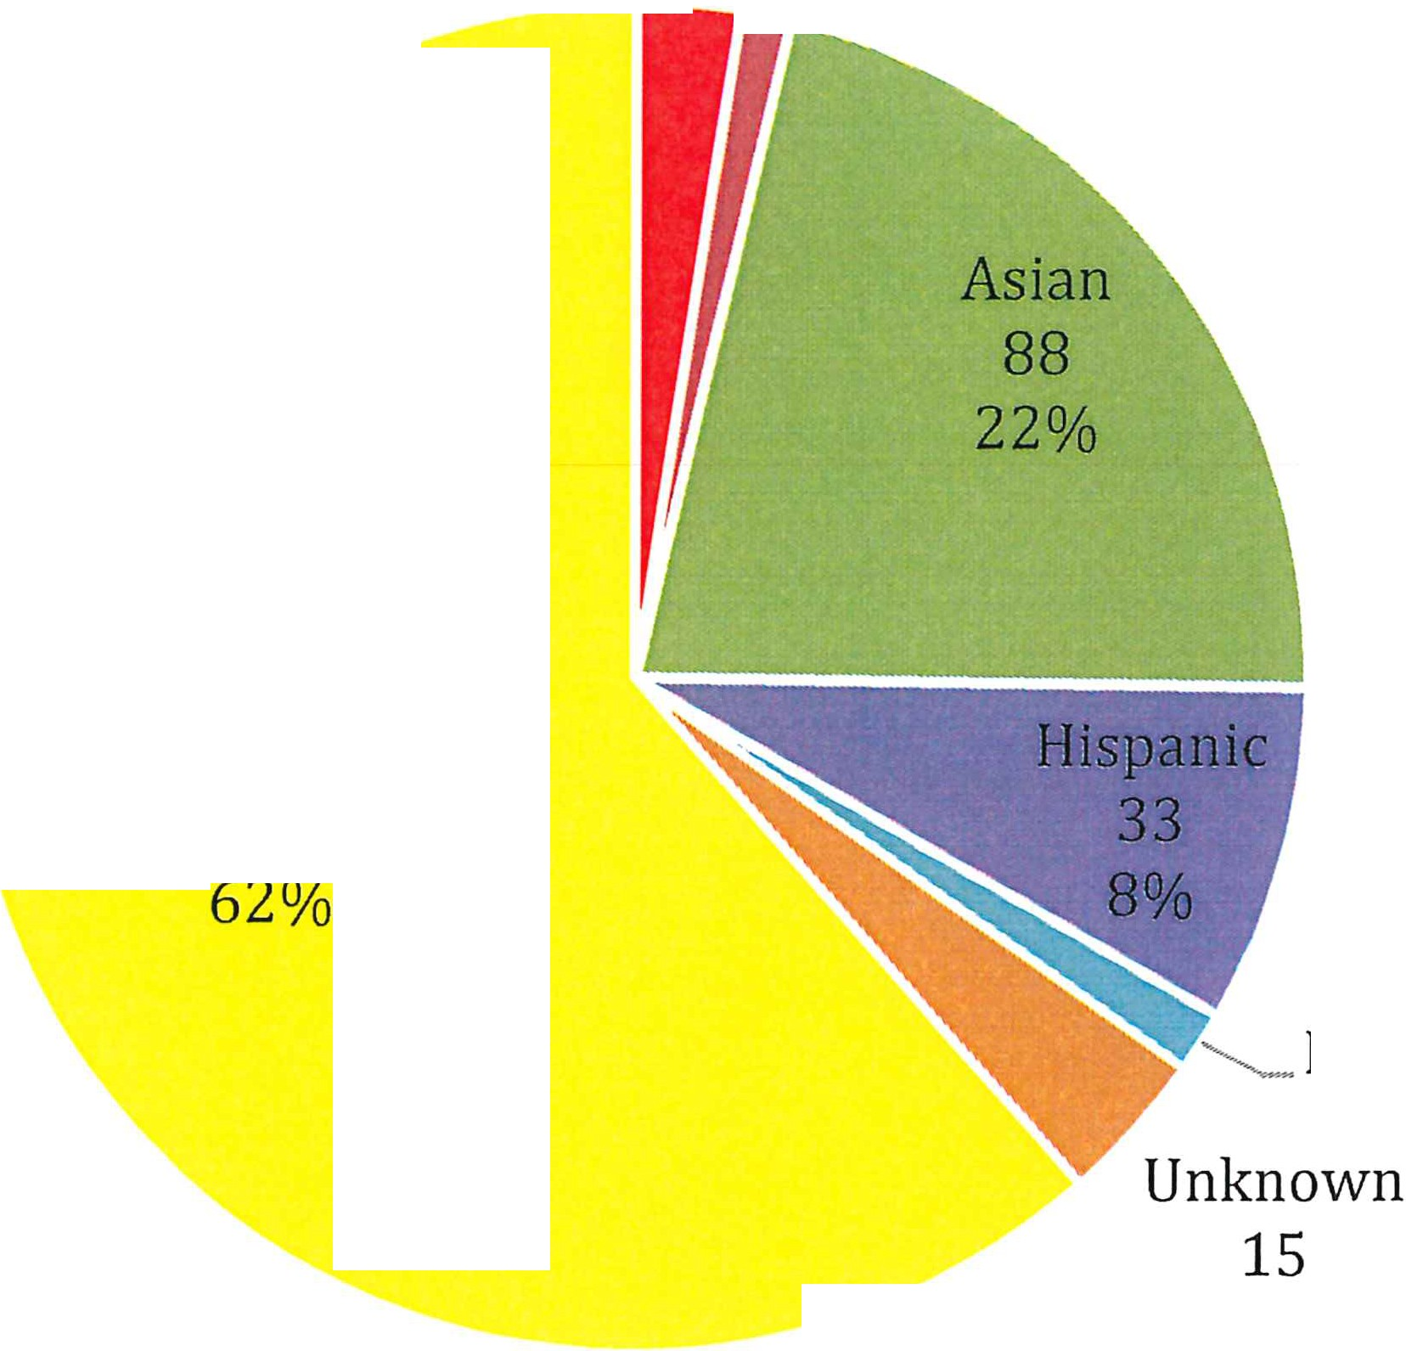10 --------

American Indian/Alaskan Native

- 5
2% 1%

White Non-Hispanic
251

'- Mu lt i-Et hnic ity
6
1%
4%

Fall 2018 Foothill Classified Employees
African-American
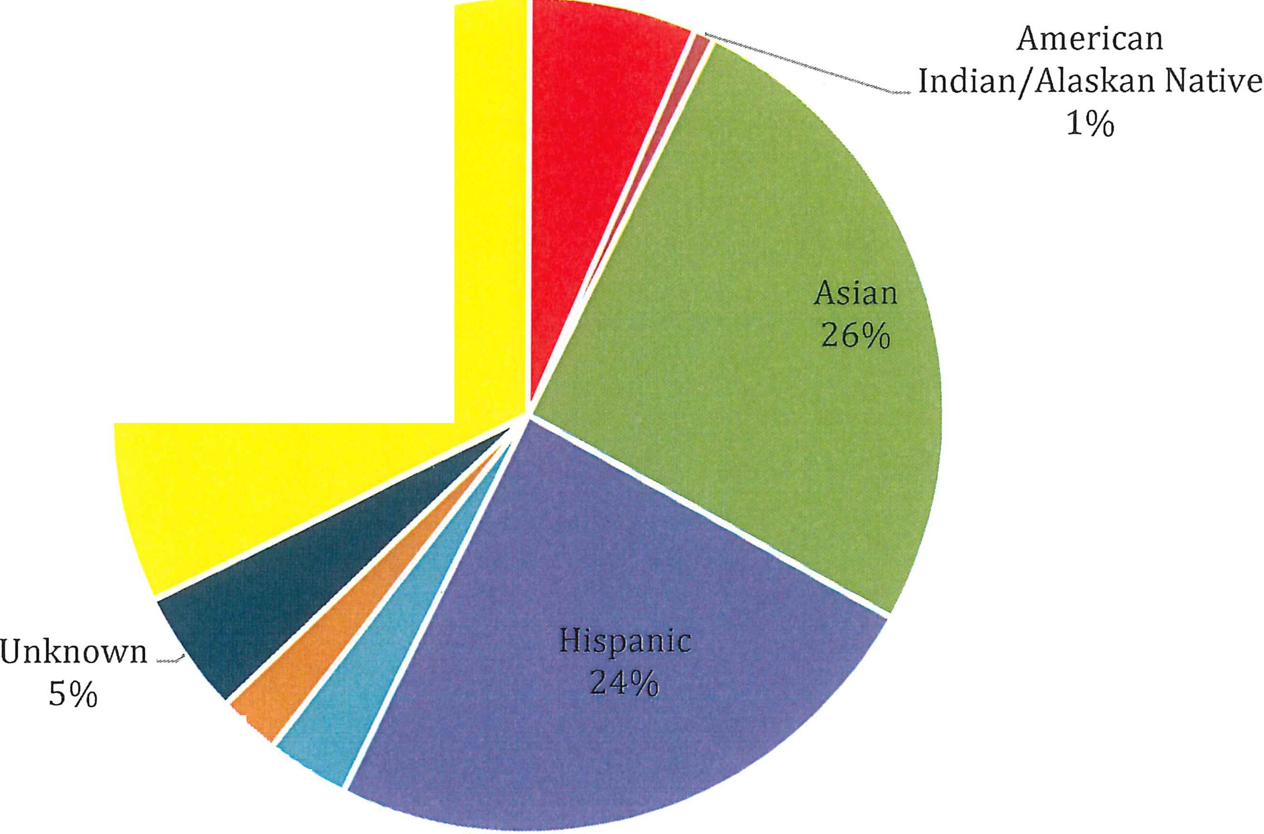7%
White Non-Hispanic
32%
Pacific Islander
2%
j

Multi-Ethnicity
3%

De Anza College (CCCCO Data Mart)

Fall 2018 De Anza Employee Demographics by Gender Count1018

Male Female

Educational Admin . 15
Educational Admin. | 6
Full-time Faculty. | 119
Part-time. | 202
Classified. | 86

Full-time Faculty. | 147
P art-time. | 257
Classified. | 186

Fall 2018 De Anza Educational Administrators

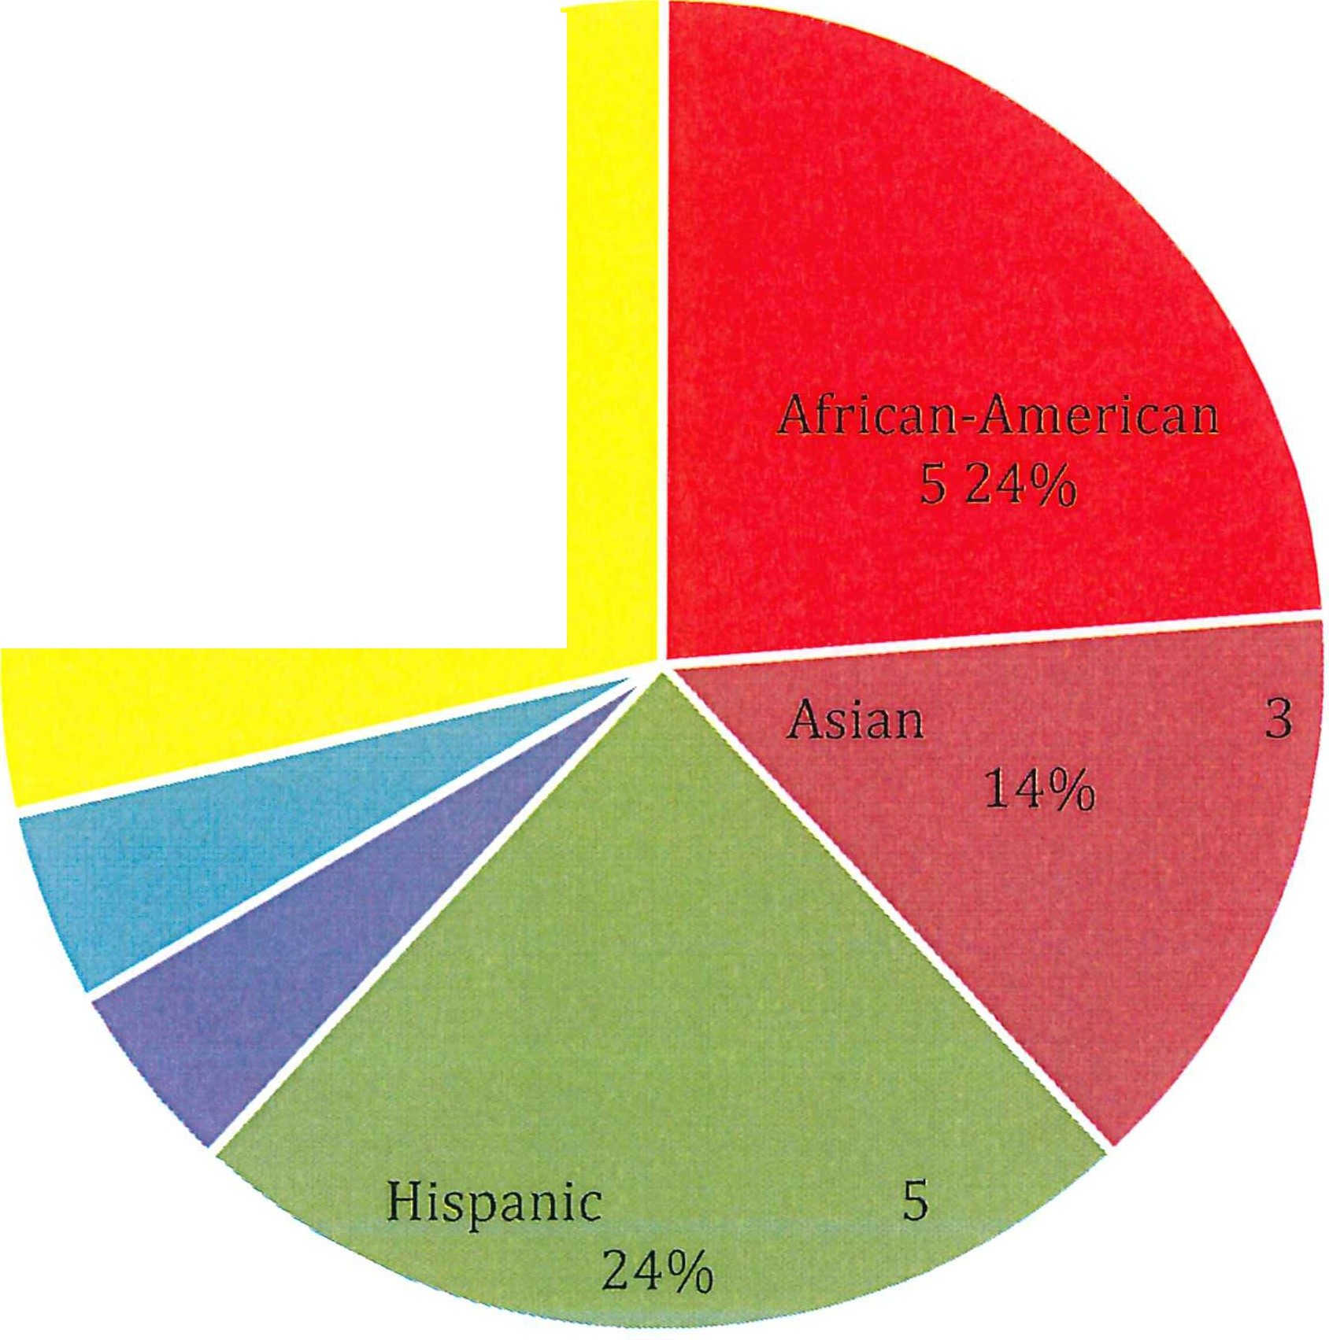Unknown
White Non-Hispanic
628%
15%

Multi-Ethnicity
15%

Fall 2018 De Anza Tenured/Tenure-track Faculty

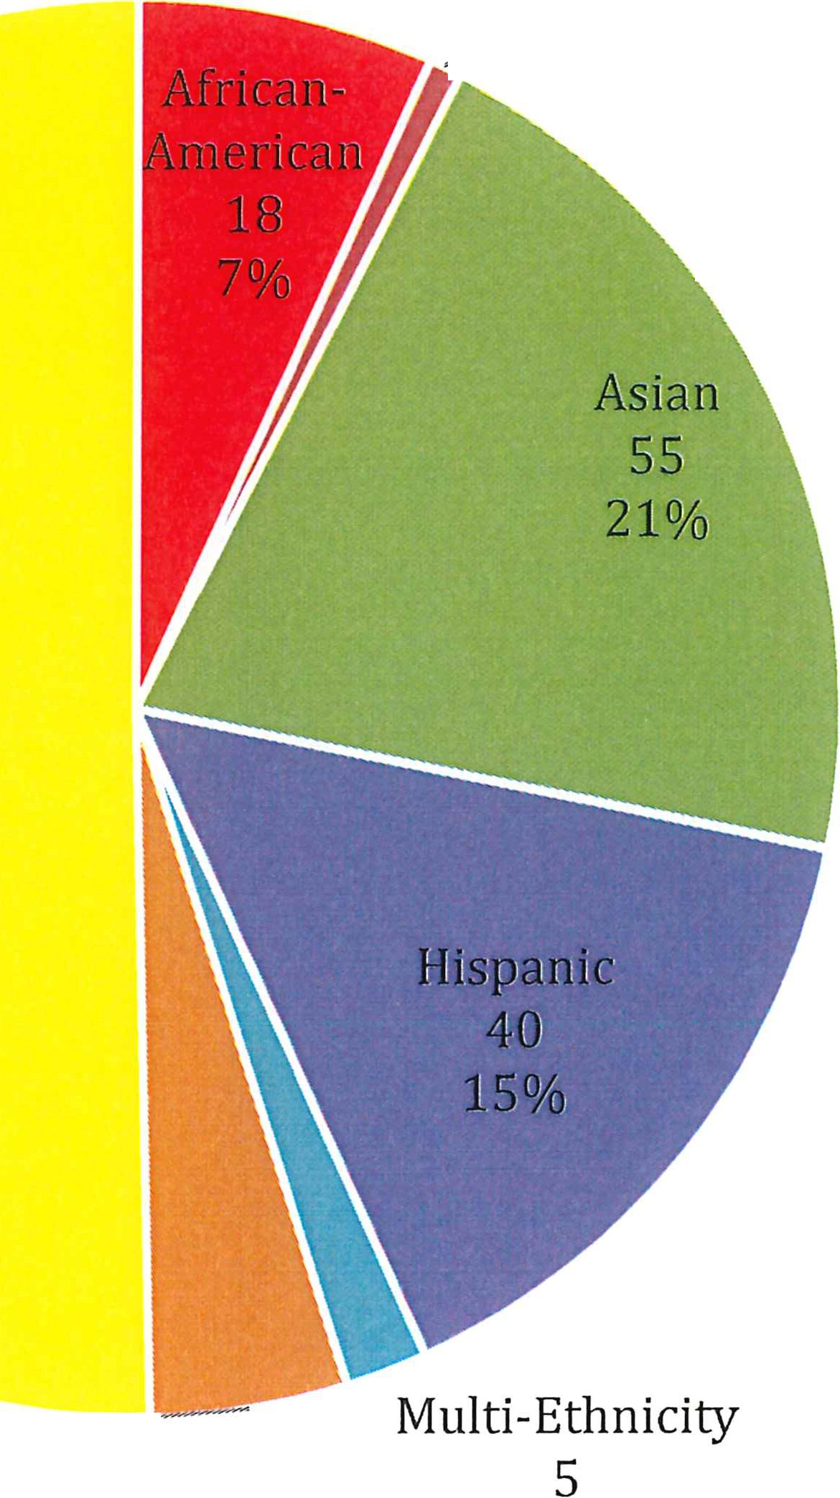
American
/ Indian/ Alaskan Native
2
1%

White Non-Hispanic 134

Un known ----=---
12
4% 2%

Fall 2018 De Anza Part-time Faculty
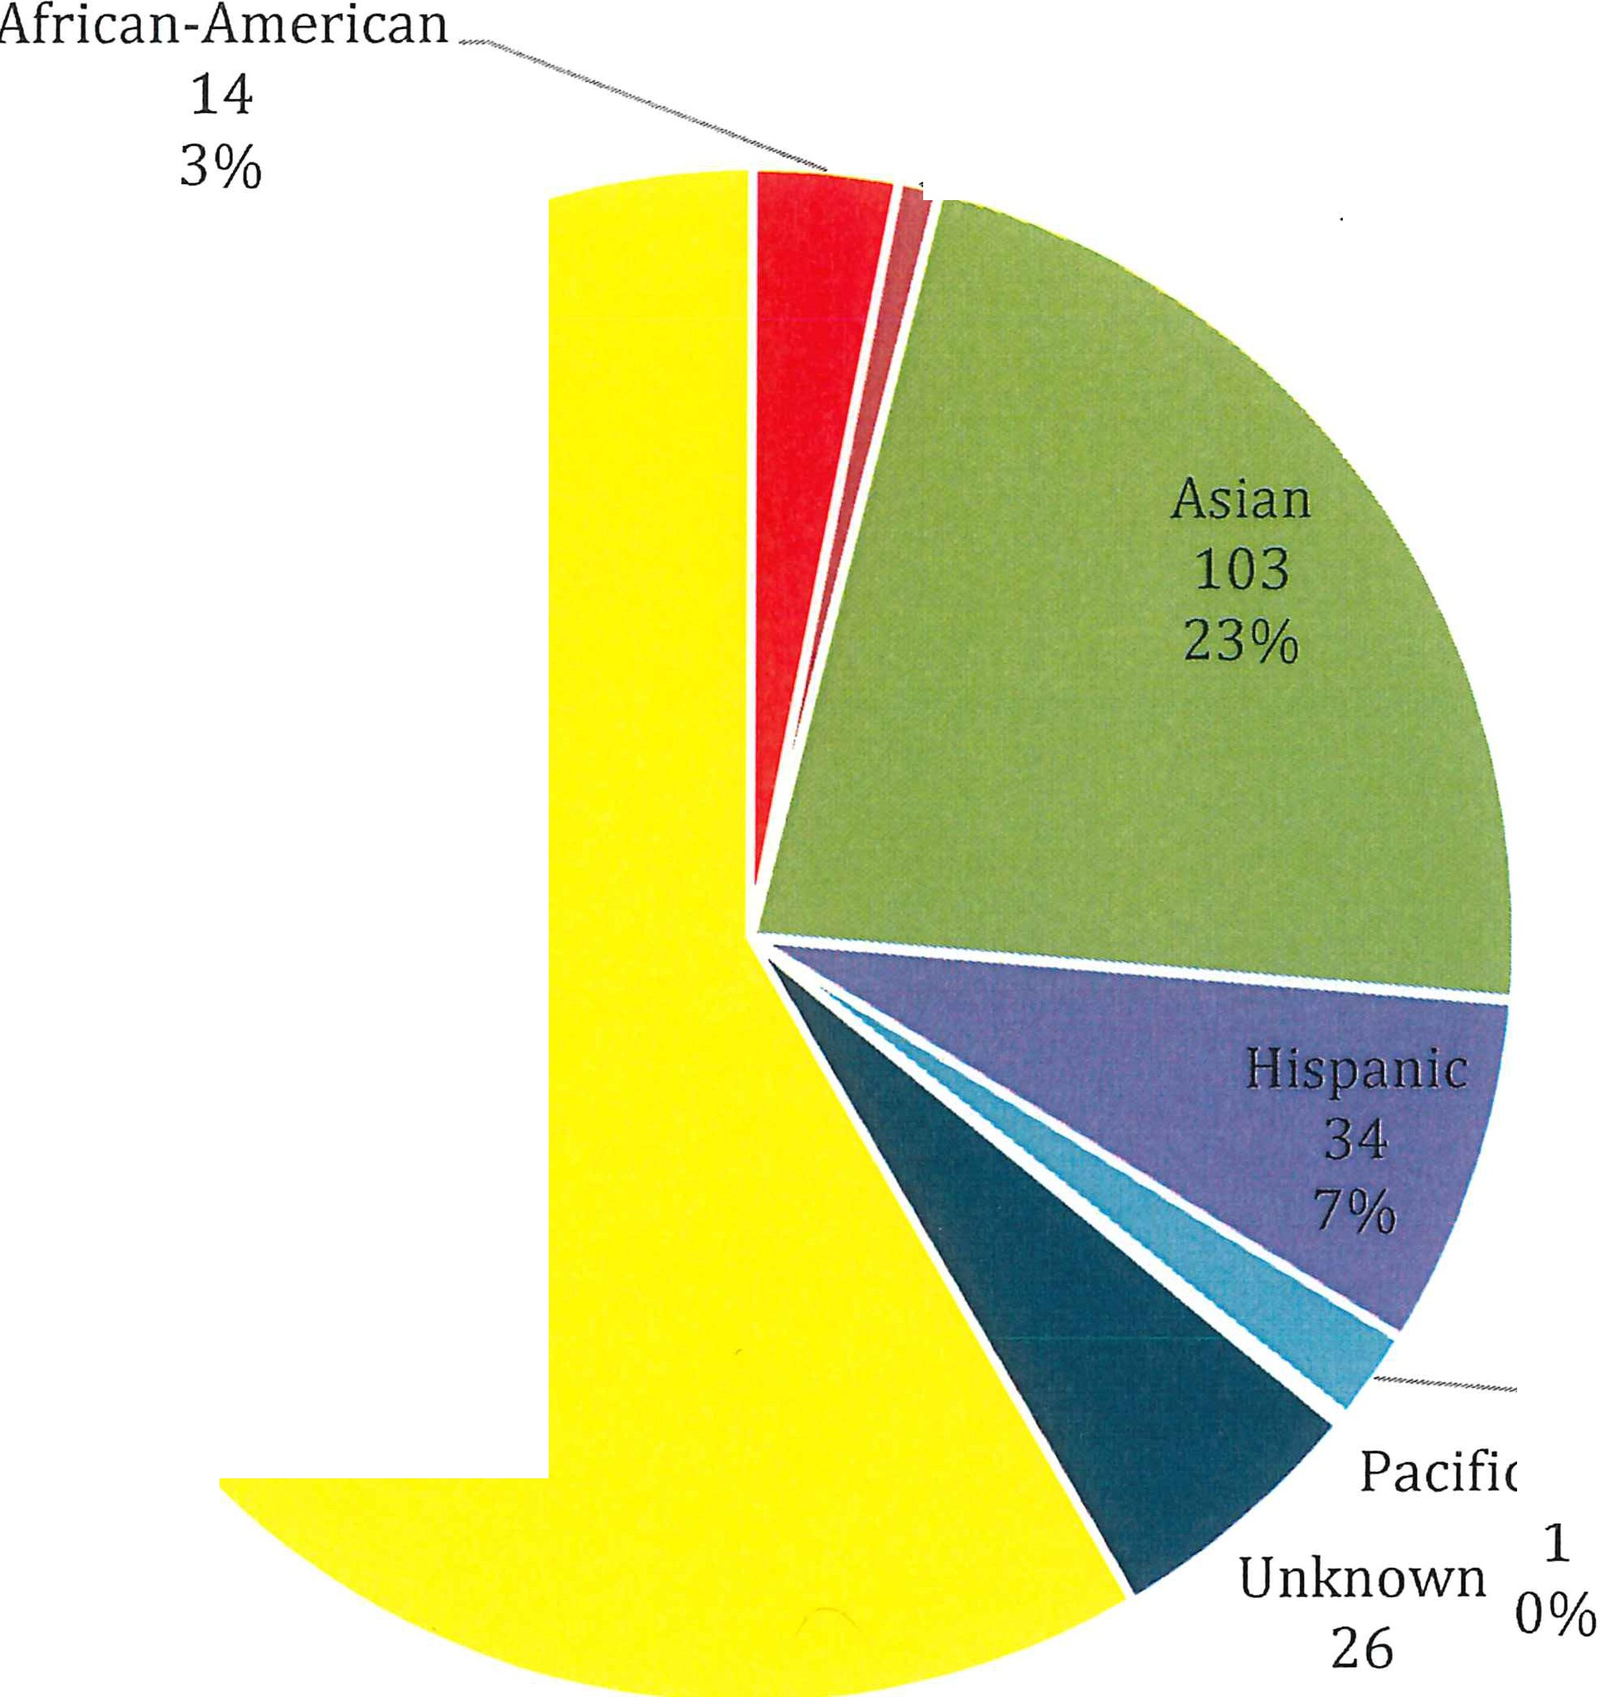American
/ Indian/ Alat an Native
. 1%

White Non-Hispanic
268
58%

- Multi-Ethnicity Pacific Islander 9
2%

6%

Fall 2018 De Anza Classified Employees
/ African- merican

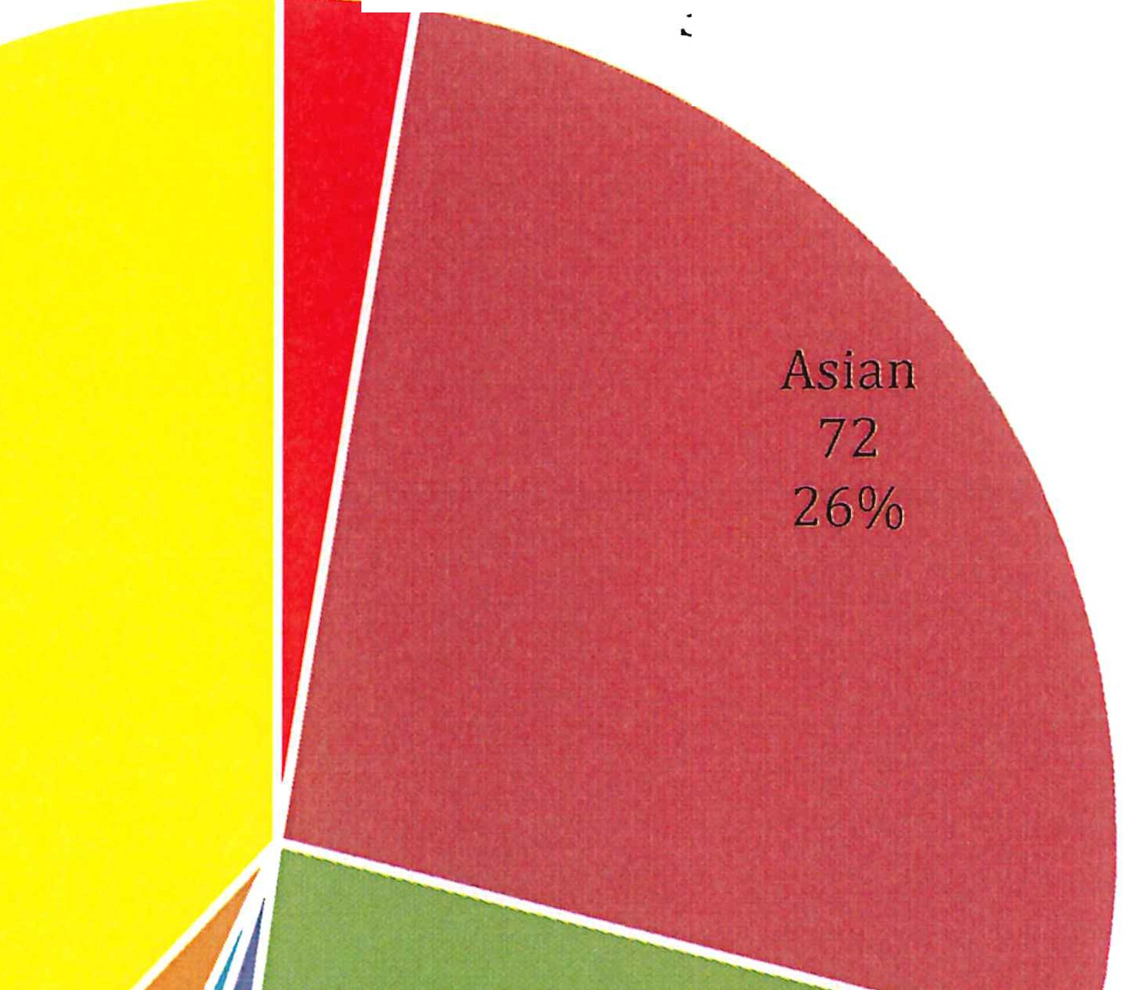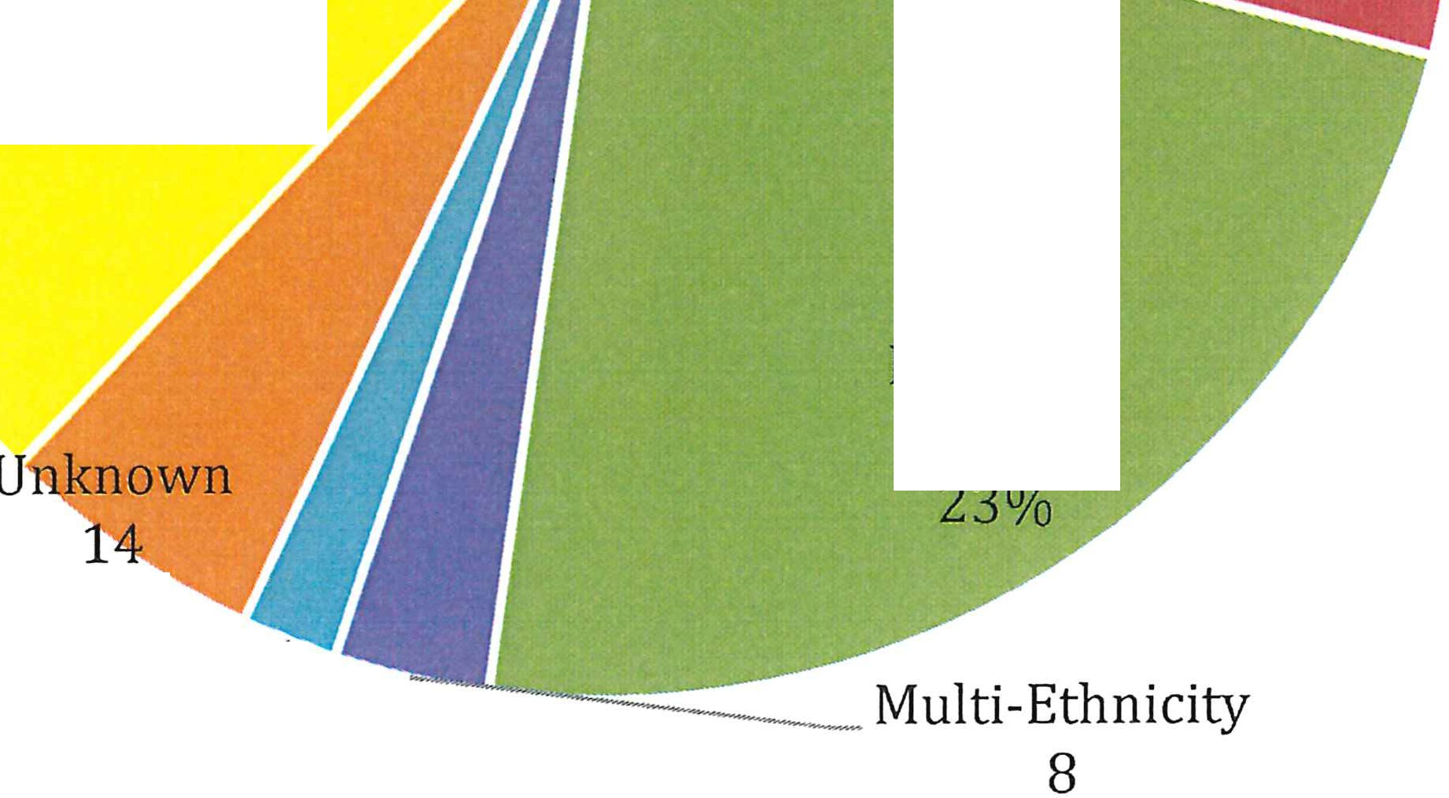3%

White Non-Hispanic
103
38%

Hispanic
63

5%
Pacific Is lander _/
5
2% 3%

Plan Component 11: Analysis of Degree of Underrepresentation and Significant Underrepresentation
Applicant Pools
Race /Ethnicity
Faculty: Whites represent the majority population of applicants, with Asians being the second largest. This was true for all faculty positions, but there was a significant jump in the number of whites and Asians applying for IO-month faculty positions when compared to 11 or 12-month faculty positions. Most other demographics applied for faculty positions at even rates, with small fluctuations.

Administrators: Whites represent the majority population of applicants.

Classified: Asian and Whites represent the majority population of applicants for clerical positions, with Asians outnumbering whites slightly. Latinx applicants represent the majority population for skilled/trades positions.

Gender
Faculty: Females represent the majority population of applicants for two years total and in each individual school year.

Administrative/Management: Males represent the majority population of applicants, although slightly.

Classified: Females represent the majority population of applicants, except in Police Officer Association and CSEA positions. Applicants were predominantly male for these positions across two years. Note: Non-binary was not an option to choose, but the District is looking to add this option once conversion to a new tracking system occurs in February 2019.

District-wide Workforce
Race/Ethnicity
Faculty: Whites represent the majority population of faculty (part-time and full-time).

Management: Whites represent the majority of educational administrators at 49%. Additionally, Hispanic and Asians each make up 15% respectively for educational administrator positions.

Classified: Classified staff are majority non-white employees, with the largest groups being Asian and Hispanic at 26% and 25% respectively.

Gender
Females represent the majority percentage in each class level for employees in the District. (Non-binary was not an option to choose.)

Plan Component 12: Methods to Address Underrepresentation
[Plan Requirement - Title 5, § 53003(c)(8)]
FHDA is in the process or has taken the following steps to address employment opportunities within our district:
- Requiring applicants to submit diversity statements indicating their commitment to diversity, equity and inclusion; providing a rating rubric to rate the diversity statement.
- Updated application procedures to remove the requirement that all transcripts be provided prior to interviews, to facilitate greater inclusion.
- Mandated EEO training for all members of hiring committees to understand implicit and unconscious bias.
e Developing Equal Opportunity Representative training to include information about Disparate Racial Impact, recruitment considerations, appropriate language to facilitate equity-centered conversations.
o Centralized procedures for assigning EO Reps to committees.
e Developed a process for review of Job Postings/Job Summaries to allow for/require equity language infusion throughout the Postings or Summaries.
- Updated Job Postings to include district mission demonstrating commitment to student success through an equity-lens.
- Encouraging the use of remote online interviews to facilitate inclusion.
- Requested that hiring managers provide additional recruitment locations/options to the District Office of Human Resources.

Plan Component 13: Additional Steps to Remedy Significant Underrepresentation
To the extent data regarding potential job applicants is provided by the State Chancellor, analysis of the degree to which monitored groups are underrepresented and/or significantly underrepresented in comparison to their representation in the field or job category in numbers of persons from such groups whom the Chancellor determines to be available and qualified to perform the work required for each such job category and whether or not the underrepresentation is significant (53003.c.7). The State Chancellor has not currently provided such job applicant information. The district will continue to implement its hiring procedures and policies in compliance with EEO regulations.

Plan Component 14: Additional Measures to Support Diversity and Ensure Equal Employment Opportunity
[Plan Requirement -Title 5, § 53003(c)(10)]
Beyond efforts to increase applicant pools and improve hiring procedures, the district recognizes that additional efforts need to be made to show a district-wide commitment to equity, diversity and inclusion. Examples of actions being taken include:

- Development of an Equity Certification program.
- District commitment to Equity-focused speakers for professional development opportunities such as Opening Day activities.
e District augmentation to campus funding to allow for greater participation in the annual National Conference on Race and Ethnicity (NCORE).
- Creation of District-wide Equity Reading Club to study publications focused on implicit bias, diversity effo1is in education, and educational equity.
@ Creation of Professional Development series offering four tracks: Hiring, Equity & Inclusion Achieved, Employee Relations, and How Inclusive are You?

Plan Component 15: Persons with Disabilities
The Foothill-De Anza Community College District is committed to the inclusion of individuals with disabilities through providing reasonable accommodations to applicants and employees in accordance with all applicable laws, statutes and District policies. Our FHDA policies addressing ability are as follows:

Board Policy 4670:
'The Board of Trustees upholds that, for persons with disabilities, improving the access to educational and employment opportunities must be a priority. The Board of Trustees directs the administration to take the necessary actions to implement the requirements of the Americans with Disabilities Act and Section 504 of the Rehabilitation Act.

The Foothill-De Anza Community College District shall not discriminate against a qualified individual with a disability because of the disability with regard to employment or with regard to the provision of District programs, services, and activities.

A person who is otherwise qualified may request accommodation related to his/her disability, provided the accommodation does not impose an undue hardship on the District. The procedures for requesting accommodation are maintained in the President's Office and the office of the ADA Coordinator on each campus and in the District Office."

From Board Policy 4105:
"The Foothill-De Anza Community College District Board of Trustees values the contributions that a diverse community of faculty, staff, and administrators makes to all the students who study at Foothill and De Anza Colleges. The Board of Trustees desires for students and for all District employees an environment where diverse cultures, abilities and needs are respected and where differences offer stimulating opportunities for learning and for personal and professional fulfillment.

Accordingly, the Board will not discriminate against any person in the provision of any program or services based on race, religious creed, color, national origin, ancestry, physical disability, mental disability, medical condition, marital status, sex, age, sexual orientation or gender identity."

Plan Component 16: Graduate Assumption Program
[Plan Requirement - Education Code§§ 87106, 69618 et seq.]
The district colleges will encourage community college students to become qualified for and seek employment as community college employees. The district and college campuses shall research and inform students about programs that may assist them to complete their graduate studies and become community college employees. The district will post informational flyers on the campuses concerning such programs, and make information available in student newspapers, the course catalog, and in locations accessible to students, including but not limited to, Counseling, Financial Aid, Admissions and Records, the Bookstore, and the Student Center.
Efforts will be made to inform graduate students in local colleges and universities about the benefits of employment at a community college.

Plan Component 17: Meeting Education Code Section 87482.6
The district will continue its efforts to comply with Education Code section 87482.6 regarding the goal of 75% instruction taught by full-time faculty, while ensuring progress toward EEO. Additionally, FHDA will continue to outreach to a diverse applicant pool for full-time and part­ time faculty, classified staff and administrators who reflect the broad cultural diversity of the students ofFHDA.

Community-based Organizations with a Commitment to Diversity

- Silicon Valley Community Foundation
2440 W El Camino Real #300, Mountain View, CA 94040

- Foothill-De Anza Foundation
12345 El Monte Rd, Los Altos Hills, CA 94022

- United Cerebral Palsy
480 San Antonio Rd, Mountain View, CA 94040

- Community Services Agency
204 Stierlin Road, Mountain View, CA 94043

- Kiwanis Club of Los Altos
P. 0. Box 484, Los Altos, CA 94023

- Rotary Club of Los Altos
P. 0. Box 794, Los Altos, CA 94023

- Haas Center for Public Service
562 Salvatierra Walk, Stanford, CA 94305

- Assistance League of Los Altos 169 State St, Los Altos, CA 94022

- West Valley Community Services 10104 Vista Dr., Cupertino, CA 95014

- People Acting In Community Together
1100 Shasta Ave Suite 210, San Jose, CA 95126

- Community Health Partnership
1401 Parkmoor Ave #200, San Jose, CA 95126

- First Community Housing
75 E Santa Clara St #1300, San Jose, CA 95113

- Los Altos Senior Center
97 Hillview Ave, Los Altos, CA 94022

- Asian Americans for Community Involvement 2400 Moorpark Ave# 300, San Jose, CA 95128

- Institute on Aging
881 Fremont Ave A2, Los Altos, CA 94024

- Palo Alto Elks Lodge
4249 El Camino Real, Palo Alto, CA 94306

- NAACP
1313 N Milpitas Blvd, Milpitas, CA 95035

- Silicon Valley Black Chamber of Commerce 25 N 14th St #505, San Jose, CA 95112

- Hispanic Chamber of Commerce
1887 Monterey Rd #215, San Jose, CA 95112

- Filipino Chamber of Commerce
2086 Walsh Ave Ste. B1, Santa Clara, California

- Abilities United
25 E Charleston Rd, Palo Alto, CA 94306

- Goodwill of Silicon Valley
2175 Grant Rd, Mountain View, CA 94040

- Mid-Peninsula Housing
1101 Grant Rd, Mountain View, CA 94040

- YMCA of Los Altos
1501 Oak Ave, Los Altos, CA 94024

- Bridges Community Church
625 Magdalena Ave, Los Altos, CA 94024

- Los Altos Community Foundation
183 Hillview Ave, Los Altos, CA 94022

- De Ambiente - Community Health Awareness Council 590 W El Camino Real, Mountain View, CA 94040

- Learning Policy Institute
1530 Page Mill Rd #200, Palo Alto, CA 94304

- De Anza Lions of Cupertino
P.O. Box 2758, Cupertino, California 95015

