Introduction to The Program Review Process for Student Services Programs

Program Review at Foothill College

Purpose
An effective program review supports continuous quality improvement to enhance student learning outcomes and, ultimately, increases student achievement rates. Program review aims to be a sustainable process that reviews, discusses, and analyzes current practices. The purpose is to encourage program reflection, and to ensure that program planning is related to goals at the institutional and course levels.

Process
Foothill College student services programs are reviewed annually using this template, with an in-depth review occurring on a three-year cycle. Faculty and staff in departments who contribute to these programs will participate in program review. Deans provide feedback upon completion of the template and will forward the program review on to the next stage of the process, including prioritization at the Vice Presidential level, and at OPC and PaRC.

Admissions & Records
Assessment
Career Center
Counseling
Disability Resource Center
EOPS
Evaluations
Financial Aid
Health Services
Judicial Affairs
Learning Resource Center
Mfumo Program
Outreach & Retention
Pass the Torch
Psychological Services
Puente Program
Student Affairs
Transfer Center

Annual program review addresses five core areas, with a final section for administrator comments and their reflections about the next steps:
1. Data and trend analysis
2. Outcomes assessment
3. Program goals and rationale
4. Program resources and support
5. Program strengths/opportunities for improvement
6. Administrator’s comments/reflection/next steps

Foothill College Program Review Cycle:
2011-2012: All programs participate in an annual program review
2012-2013: 1/3 of programs participate in a comprehensive review, remaining 2/3 of programs update their annual program review

Contact: Office of Instruction and Institutional Research (650) 949-7240
Website: http://foothill.edu/staff/irs/programplans/index.php
Submission Deadline: All program review documents are due to Deans by December 16
Basic Program Information

Student Service Program Name:

Student Service Program Mission:

Program Review Team:
Name | Department | Position

Section 1. Data and Trend Analysis

1.1. Program/Department Data

Dimension | 2008-2009 | 2009-2010 | 2010-2011
Students Served
Full-time FTEF
Part-time FTEF
Full-time Staff
Part-time Staff

1.2 Using the data provided above, include a short narrative analysis of the following indicators. Please attach supporting studies or data to the final program review submitted to your Dean.

- Students served (How was this tracked? What is the trend?):
- Demographics analysis (Is the ethnic breakdown of students you serve proportional to the general college ethnic distribution?)
- Staffing structure (Does the staffing structure meet the program’s or department’s needs? If yes, please explain. If not, consider the following prompts in framing your answer.)
    - Which aspects of the work are key to the institution’s mission?
    - Has the staff increased, decreased or remained the same to meet those changes?
    - Has technology made it possible to do more work with the same staff? Or, has technology increased your workload (adding web features which need updating for example)? In what way?
    - Does the workload have significant peaks and valleys during the fiscal year? If so, describe.
    - Do you anticipate the workload will increase, decrease or remain constant in the upcoming one to three years? Is this a temporary situation?
    - If your workload is increasing and resources will not allow for increased staffing, how do you anticipate being able to ameliorate the negative consequences of too much work and maintain a positive atmosphere?
    - What steps can be taken to improve your program or department’s organizational efficiency within its current budget?
    - What strategies have been used to improve the delivery of support services within the program or department?
- Workload measures (includes budget details). Describe the program’s workload measures as developed within the Student Services process.
- Budget analysis categories of expenditures (A Budget, Equipment, Supplies)
- Basic skills programs (If applicable)
- Transfer programs: (If applicable)
- CTE programs: Labor/Industry alignment (If applicable)

Section 2. Learning Outcomes Assessment Summary

2.1. Insert – Previous year’s Four Column Report for SA-SLO Assessment from TracDat, please contact the Office of Instruction to assist you with this step if needed.

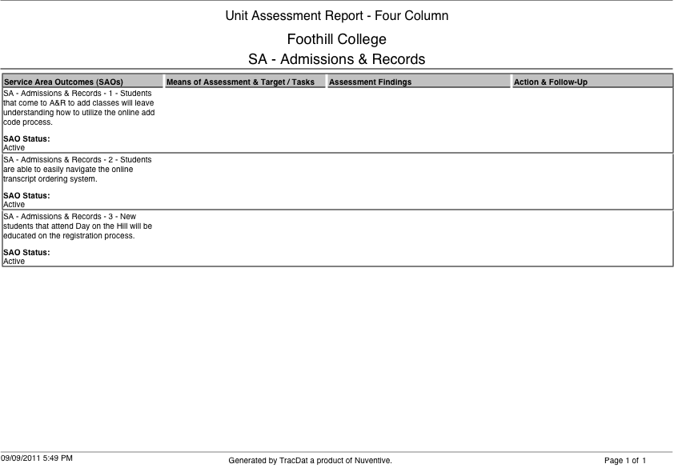

2.3 Please provide observations and reflections below.

2.3.a Service Area Student Learning Outcomes
What findings can be gathered from the SA-SLOs assessments?

2.3.b Does any of the data suggest that revisions might be necessary in order for students to successfully achieve the SA-SLOs?

2.3.c Do the SA-SLOs reflect the knowledge, skills and abilities students need from those services in order to succeed?

2.3.d How has assessment of SA-SLOs led to improvement in student success at the institution?

2.4 Annual Action Plan and Summary: Using the information above, list the program’s action steps, the related Core Mission objective, SLO assessment data and the expected impact on student success.
Action Step | Related SA-SLO assessment (Note applicable data) | Related ESMP Core Mission Goals (Basic Skills, Transfer, Work Force, Stewardship of Resources) | How will this action improve student learning/success?

Section 3: Program Goals and Rationale

Program goals should be broad and incorporate some sort of measurable action that connects to Foothill’s core missions, Educational & Strategic Master Plan (ESMP), the division plan, and SLOs.

3.1 Program relation to college mission/core missions

3.2 Previous program goals from last academic year
Goal | Original Timeline | Actions Taken | Status/Modifications

3.3 New Goals: Goals can be multi-year
Goal | Timeline (long/short-term) | Supporting Action Steps from section 2.4 (if applicable) | How will this goal improve student success?

Section 4: Program Resources and Support

4.1 Using the tables below to summarize your program’s resource requests.

Full Time Faculty and/or Staff
Position | $ Amount | Related Goal from Table in section 3.3 | Possible funding sources (Lottery, Measure C, Basic Skills, Perkins, etc.)

B Budget Augmentation
B Budget FOAP | $ Amount | Related Goal from Table in section 3.3 | Possible funding sources (Lottery, Measure C, Basic Skills, Perkins, etc.)

Facilities and Equipment
Facilities/Equipment Description | $ Amount | Related Goal from Table in section 3.3 | Possible funding sources (Lottery, Measure C, Basic Skills, Perkins, etc.)

One-time/Other: (Release time, training, etc.)
Description | $ Amount | Related Goal from Table in section 3.3 | Possible funding sources (Lottery, Measure C, Basic Skills, Perkins, etc.)

Section 5: Program Strengths/Opportunities for Improvement

5.1 Use the matrix provided below and reflecting on the program relative to students’ needs, briefly analyze the program’s strengths and weaknesses and identify opportunities and challenges to the program. Consider external and internal factors, such as demographic, economic, educational, and societal trends. Some considerations may include current and future demand for the program, similar programs at other comparable institutions, and potential auxiliary funding.

 | Internal Factors | External Factors
Strengths | Example: Program has begun to update paperwork and become aligned with College processes. | Example: Program has an excellent reputation in the surrounding dental community. Graduates find employment easily.
Weaknesses | In the past, the Program was left on its own without enough administrative support and/or guidance. This has left the Program with a lot of catching up and repair work to accomplish. The Program has been ignorant, but is quickly learning, to the many processes and protocols the College is responsible for. | Students are often unaware that Foothill has a Dental Assisting Program or are told that Foothill does not have a Dental Assisting Program.
Opportunities | 1) Program is moving into a new building with new equipment with a more centralized location.  2) Professional Development through CADAT to strengthen current faculty | A local dentist wants to donate $30,000.00 to the Dental Assisting Program.
Threats | The state of the budget, VTEA funds are threatened, and Dental Assisting has little to no supplies budget. | Proprietary Schools that offer Dental Assisting Programs

5.2 Are there any critical issues you expect to face in the coming year? How will you address those challenges?

5.3 What statements of concern have been raised in the course of conducting the program review by faculty, administrators, students, or by any member of the program review team regarding overall program viability?

5.4 Address the concerns or recommendations that were made in prior program review cycles.

5.5 After reviewing the data, what strengths or positive trends would you like to highlight about your program?

Section 6: Feedback and Follow Up

This section is for the Dean to provide feedback.

6.1 Strengths and successes of the program as evidenced by the data and analysis:

6.2 Areas of concern, if any:

6.3 Recommendations for improvement:

6.4 Recommended next steps:
___ Proceed as planned on program review schedule
___ Further review/Out of cycle in-depth review

