Introduction
Purpose
An effective program review supports continuous quality improvement to enhance student learning outcomes and, ultimately, increase student achievement rates. Program review aims to be a sustainable process that reviews, discusses, and analyzes current practices. The purpose is to encourage program reflection, and to ensure that program planning is related to goals at the institutional and course levels.

Process
Foothill College student services programs are reviewed annually, with an in-depth review occurring on a three-year cycle. Faculty and staff in departments who contribute to these programs will participate in program review. Deans provide feedback upon completion of the template and will forward the program review on to the next stage of the process, including prioritization at the Vice Presidential level, and at OPC and PaRC.

Annual program review addresses five core areas, with a final section for administrator comments and their reflections about the next steps:
1. Data and trend analysis
2. Outcomes assessment
3. Program goals and rationale
4. Program resources and support
5. Program strengths/opportunities for improvement
6. Administrator’s comments/reflection/next steps
7. Vice President’s comments

2012-2013 Submission Deadline:
• Program review documents are due to Director/Dean by December 14 for completion of Section 6.
• Director/Dean completes section 6 and forwards documents to Vice President for completion of Section 7 by January 4, 2013.
• Vice President completes section 7 and returns documents to program review team by January 18, 2013.
• Program review documents are due to the Office of Instruction by January 25, 2013.

Foothill College Program Review Cycle:
To see which template your department is scheduled to complete, check the Program Review Schedule: http://foothill.edu/staff/irs/programplans/2012-2013/12-13-prog-rev-schedule.pdf

Questions?
Contact: Office of Instruction and Institutional Research (650) 949-7240
Website: http://foothill.edu/staff/irs/programplans/index.php

Basic Program Information

Student Service Program Name:

Student Service Program Mission:

Total number of Full Time Faculty:
Total number of Part Time Faculty:

Existing Classified positions:
Example: Administrative Assistant I
Example: Program Coordinator

Program Review Team and Departments:
Name | Department | Position

Section 1. Data and Trend Analysis

1.1. Program/Department Data

Dimension | 2009-2010 | 2010-2011 | 2011-2012
Students Served
Full-time FTEF
Part-time FTEF
Full-time Staff
Part-time Staff

1.2 Using the data provided above, include a short narrative analysis of the following indicators. Please attach supporting studies or data to the final program review submitted to your Dean.

- Students served (How was this tracked? What is the trend?):
- Demographics analysis (Is the ethnic breakdown of students you serve proportional to the general college ethnic distribution?)
- Please describe services offered off campus and how these services are assessed and measured.
- Staffing structure (Does the staffing structure meet the program or department’s needs? If yes, please explain. If not, consider the following prompts in framing your answer.)
    - Which aspects of the work are key to the institution’s mission?
    - Has the staff increased, decreased or remained the same to meet those changes?
    - How has technology affected the workload in your office?
    - Does the workload have significant peaks and valleys during the year? If so, describe.
    - Do you anticipate the workload will increase, decrease or remain constant in the upcoming one to three years? Is this a temporary situation?
    - What steps can be taken to improve your program or department’s organizational efficiency within its current budget?
    - What strategies have been used to improve the delivery of support services within the program or department?
- Budget analysis categories of expenditures. Use table below to list expenditure categories and budgeted amounts (add categories if needed):
Account Category | Budgeted Amount | Description of Common Charges
Contractor
Copy Costs/Printing
Equipment
Pro Card
Software
Stipends
Travel
- Basic Skills Programs (if applicable). For more information about the Core Mission of Basic Skills, see the Basic Skills Workgroup website: http://foothill.edu/president/basicskills.php
  - Please discuss current outcomes or initiatives related to this core mission.
- Transfer Programs (if applicable). For more information about the Core Mission of Transfer, see the Transfer Workgroup website: http://foothill.edu/president/transfer.php
  - Please discuss current outcomes or initiatives related to this core mission.
- Workforce/Career Technical Education Programs (if applicable). For more information about the Core Mission of Workforce, see the Workforce Workgroup website: http://foothill.edu/president/workforce.php
  - Please discuss current outcomes or initiatives related to this core mission.
- Student Equity: Foothill-De Anza Community College District Board policy and California state guidelines require that each California community college submit a report on the college’s progress in achieving equity in five specific areas: access, course completion, ESLL and basic skills completion, degree and certificate completion, and transfer. For the latest draft of the Student Equity Report, please see the ESMP website: http://foothill.edu/staff/irs/ESMP/index.php
  - To better inform the Student Equity efforts at Foothill College, please comment on any current outcomes or initiatives related to increasing outreach, retention and student success of underrepresented students in your program.
- Innovation: Please comment on any innovative initiatives within your program, this could include areas regarding sustainability, stewardship of resources, collaboration, grants and/or curriculum.

Section 2. Learning Outcomes Assessment Summary

2.1. Insert – 2011-2012 Four Column Report for SA-SLO Assessment from TracDat, please contact the Office of Instruction to assist you with this step if needed.

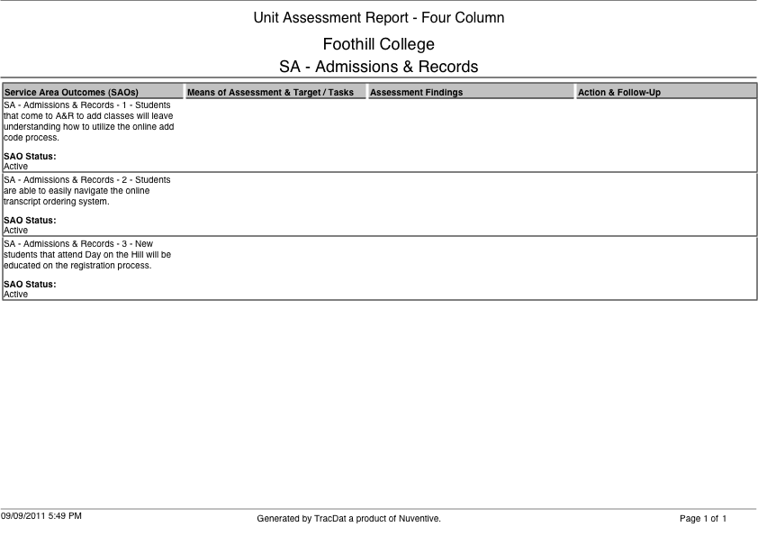

2.3 Service Area Student Learning Outcomes: Please provide observations and reflections below.

2.3.a What findings can be gathered from the SA-SLOs assessments?

2.3.b Does any of the data suggest that revisions might be necessary in order for students to successfully achieve the SA-SLOs?

2.3.c Do the SA-SLOs reflect the knowledge, skills and abilities students need from those services in order to succeed?

2.3.d How has assessment of SA-SLOs led to improvement in student success at the institution?

2.4 Annual Action Plan and Summary: Using the information above, list the Service Area’s action steps, the related Core Mission objective, SLO assessment data and the expected impact on student success.

Action Step | Related SLO assessment (Note applicable data) | Related ESMP Core Mission Goals (Basic Skills, Transfer, Work Force, Stewardship of Resources) | How will this action improve student learning/success?
1
2
3

Section 3: Program Goals and Rationale

Program goals should be broad and incorporate some sort of measurable action that connects to Foothill’s core missions, Educational & Strategic Master Plan (ESMP), the division plan, and SLOs. Goals will be linked to resource requests.

3.1 Previous program goals from last academic year
Goal | Original Timeline | Actions Taken | Status/Modifications

3.2 New Goals: Goals can be multi-year

Goal | Timeline (long/short-term) | How will this goal improve student success or respond to other key college initiatives | Action Steps

Section 4: Program Resources and Support

4.1 Using the tables below, summarize your program’s new, unfunded resource requests. Refer to the Operations Planning Committee website: http://foothill.edu/president/operations.php for current guiding principles, rubrics and resource allocation information.

Full Time Faculty and/or Staff Positions
Position | $ Amount | Related Goal from Table in section 3.2 and/or rationale

Unbudgeted Reassigned Time (calculate by % reassign time x salary/benefits of FT)
Position | $ Amount | Related Goal from Table in section 3.2 and/or rationale

One-time B Budget Augmentation
Description | $ Amount | Related Goal from Table in section 3.2 and/or rationale

Ongoing B Budget Augmentation
B Budget FOAP | $ Amount | Related Goal from Table in section 3.2 and/or rationale

Facilities and Equipment
Facilities/Equipment Description | $ Amount | Related Goal from Table in section 3.2 and/or rationale

Section 5: Program Strengths/Opportunities for Improvement

5.1 Use the matrix provided below and, reflect on the program relative to students’ needs, briefly analyze the program’s strengths and weaknesses and identify opportunities and challenges to the program. Consider external and internal factors, such as demographic, economic, educational, and societal trends. Some considerations may include current and future demand for the program, similar programs at other comparable institutions, and potential auxiliary funding.

 | Internal Factors | External Factors
Strengths | Example: Program has begun to update paperwork and become aligned with College processes. | Example: Program has an excellent reputation in the surrounding dental community. Graduates find employment easily.
Weaknesses | Example: In the past, the Program was left on its own without enough administrative support and/or guidance. This has left the Program with a lot of catching up and repair work to accomplish. The Program has been ignorant, but is quickly learning, to the many processes and protocols the College is responsible for. | Example: Students are often unaware that FH has a Dental Assisting Program or are told that FH does not have a Dental Assisting Program.
Opportunities | Example: 1) Program is moving into a new building with new equipment with a more centralized location.  2) Professional Development through CADAT to strengthen current faculty | Example: A local dentist wants to donate $30,000.00 to the Dental Assisting Program.
Threats | Example: The state of the budget, VTEA funds are threatened, and Dental Assisting has little to no supplies budget. | Example: Proprietary Schools that offer Dental Assisting Programs

5.2 Address the concerns or recommendations that were made in prior program review cycles.

5.3 What statements of concern have been raised in the course of conducting the program review by faculty, administrators, students, or by any member of the program review team regarding overall program viability?

5.4 After reviewing the data, what strengths or positive trends would you like to highlight about your program?

Section 6: Feedback and Follow Up

This section is for the Director and/or Dean to provide feedback.

6.1 Strengths and successes of the program as evidenced by the data and analysis:

6.2 Areas of concern, if any:

6.3 Recommendations for improvement:

6.4 Recommended next steps:
___ Proceed as planned on program review schedule
___ Further review/Out of cycle in-depth review

Section 7: Feedback and Follow Up

This section is for the Vice President to provide feedback.

6.1 Strengths and successes of the program as evidenced by the data and analysis:

6.2 Areas of concern, if any:

6.3 Recommendations for improvement:

6.4 Recommended next steps:
___ Proceed as planned on program review schedule
___ Further review/Out of cycle in-depth review

Upon completion of section 7, the Program Review should be returned to department faculty and staff for review, then submitted to Instruction and Institutional Research for public posting. See timeline on page 1.

